Sigi3 Access Instructions

Find Sigi3 by going to this link: http://www.sigi3.org/login.asp?SQ=1274&SK=8970896505
OR, you may go to the Career Development Center Website www.uc.edu/ career
Then open the “Students/Alumni” tab. Click on “Career Exploration,” and then “Assess Your Values, Interests, Personality, and Skills.” Scroll down to “Sigi3” and you’ll see a link to the assessment.

Sigi has many pieces that you can use to keep your career plan on track. Feel free to look at all the content and use it as you choose.

On your first visit, set up your user ID using the NEW MEMBERS frame on the login screen. On subsequent visits to SIGI3, enter your ID and password in the EXISITING MEMBERS frame.
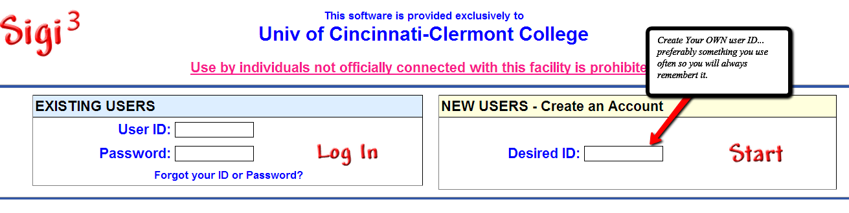

2. complete the assessment: To launch your career search you will go into the Sigi3 website using your own user ID and password. Once there you will look at the 2nd box:
Complete EACH Section in Surveys using Cards, Pairs, and Qik Pik Including:
Values
Interests
Personality
Skills

You will complete the three Assessments Values, Interests, and Personality using all three options, Pairs, Cards, and QikPik. Skills will only ask you whether you feel you are Good or Not Good at the skills listed.

Once you have completed the assessments you may click on the career options for each piece of the assessment.

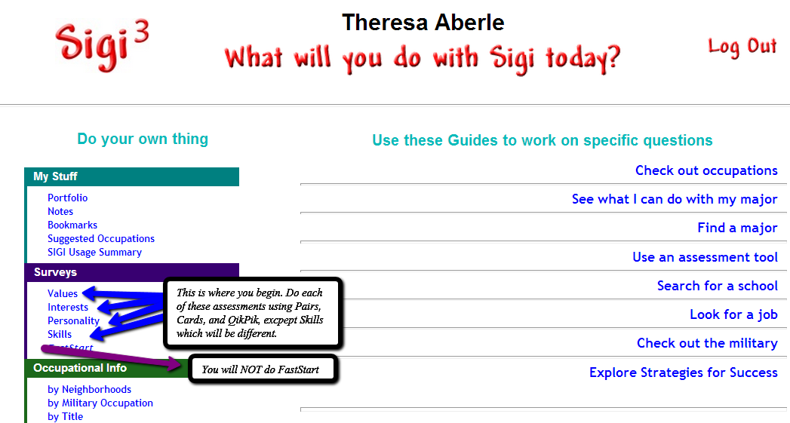

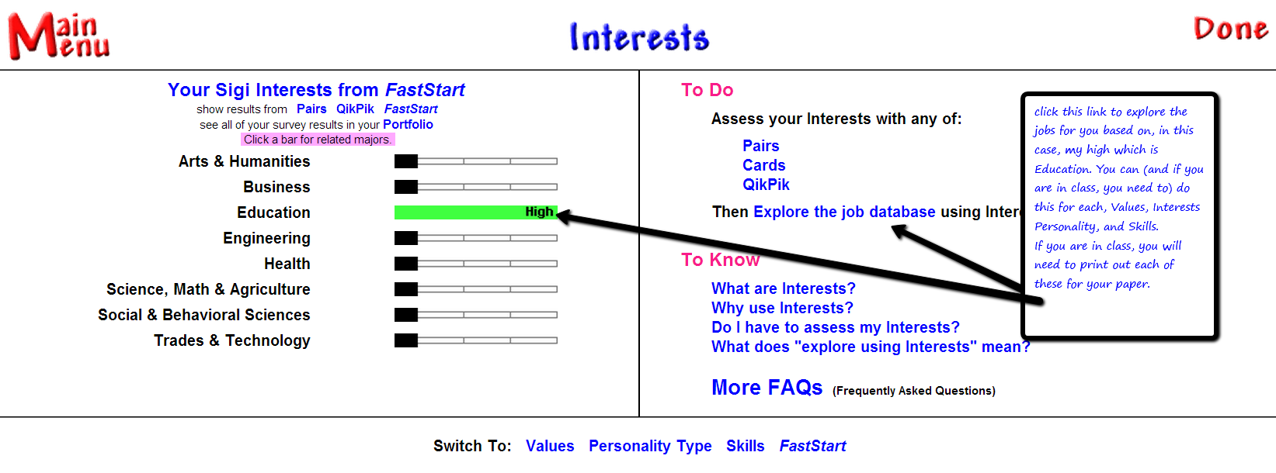
Do each assessment all 3 ways

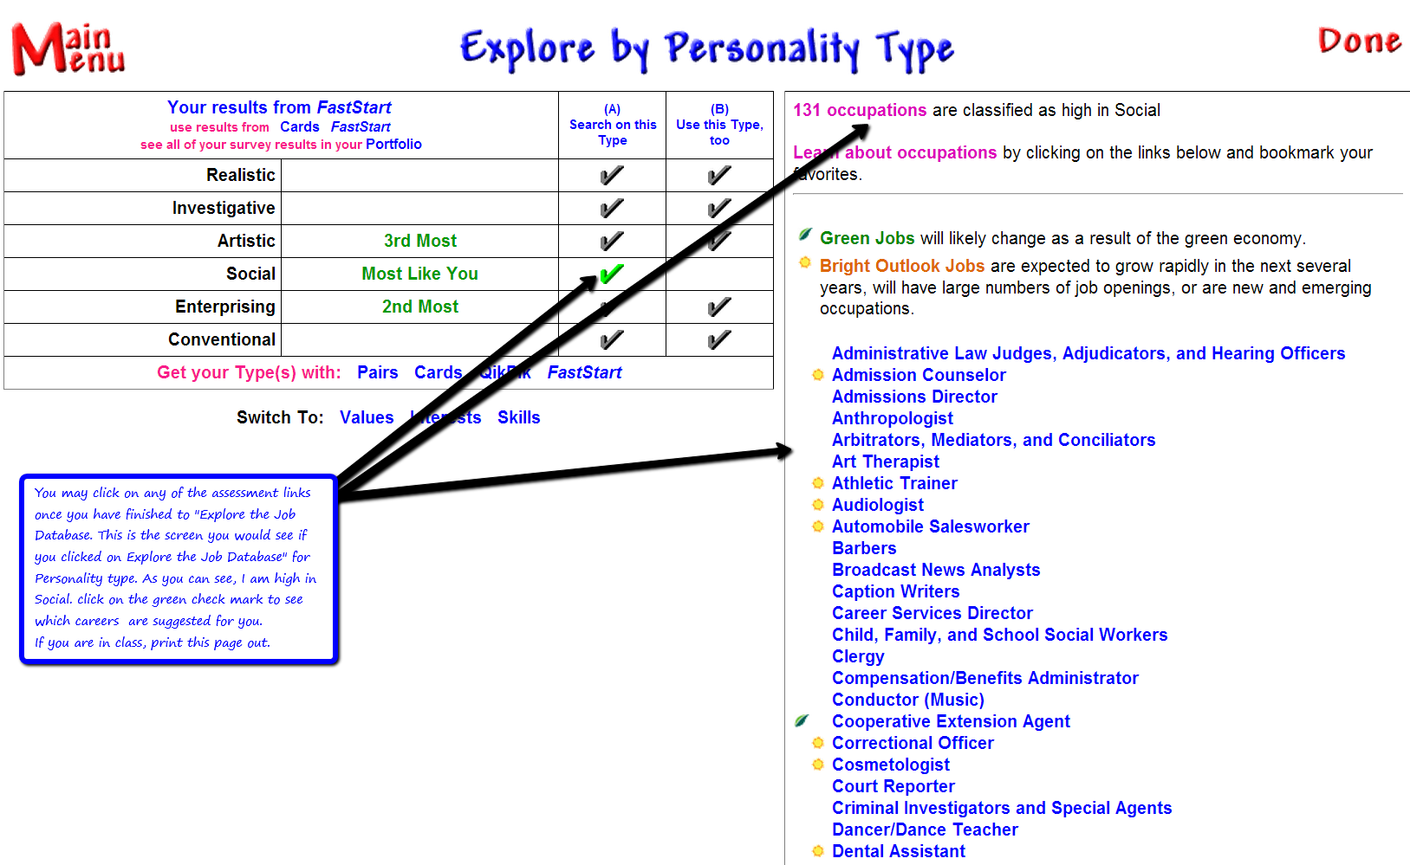

Here you can explore occupations, both those given you from the assessment as well as any that you have considered.

You can explore occupations using several tools in SIGI 3 including:
- Search by Occupation Name: Explore over 1,000 occupations
- Search by Industry: Explore occupations associated with an industry area.
- Compare Two Occupations Side by Side This feature offers a side by side comparison of any two occupations you select.
- Build a list of occupations for a Factor-by-Factor comparison You can look at up to 8 career choices side by side in a grid to quickly eliminate those that do not have your main characteristics rated essential or very high according to your indicators in the assessments.
- Bookmark: Save Occupations that interest you so you can find them easily This will allow you to bookmark the occupations you would like to compare either side by side or in a grid. This feature will come in handy to write your paper.

The Portfolio will allow you to see all your information in one place. You should be able to see all the results for each assessment, and that you have completed them all 3 ways.

The “Personality FAQs” will give you your RIASEC based on this assessment’s responses.

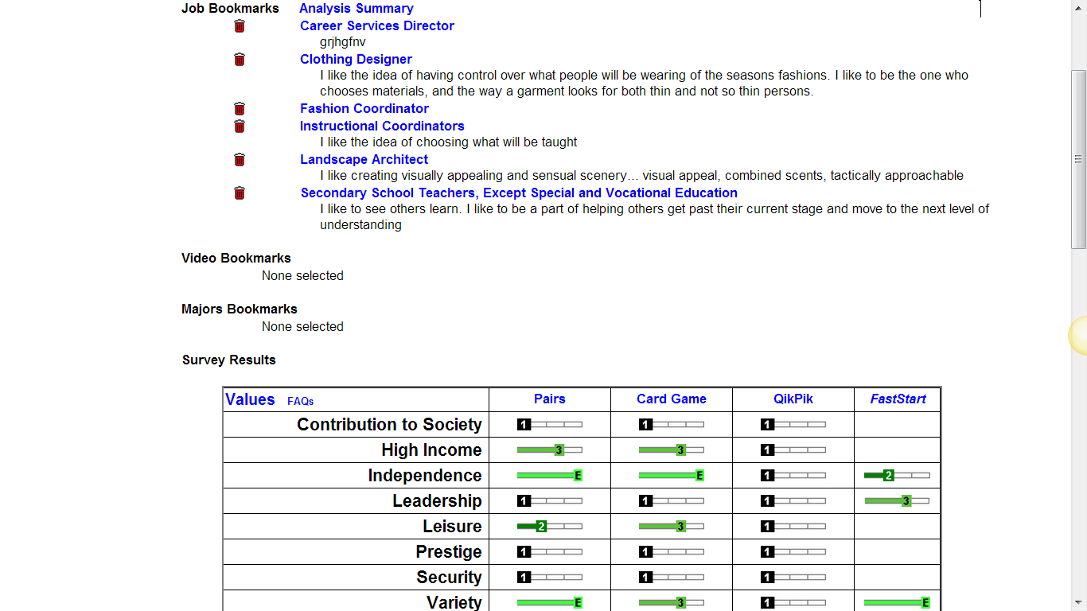
Not done
Do all 3 ways
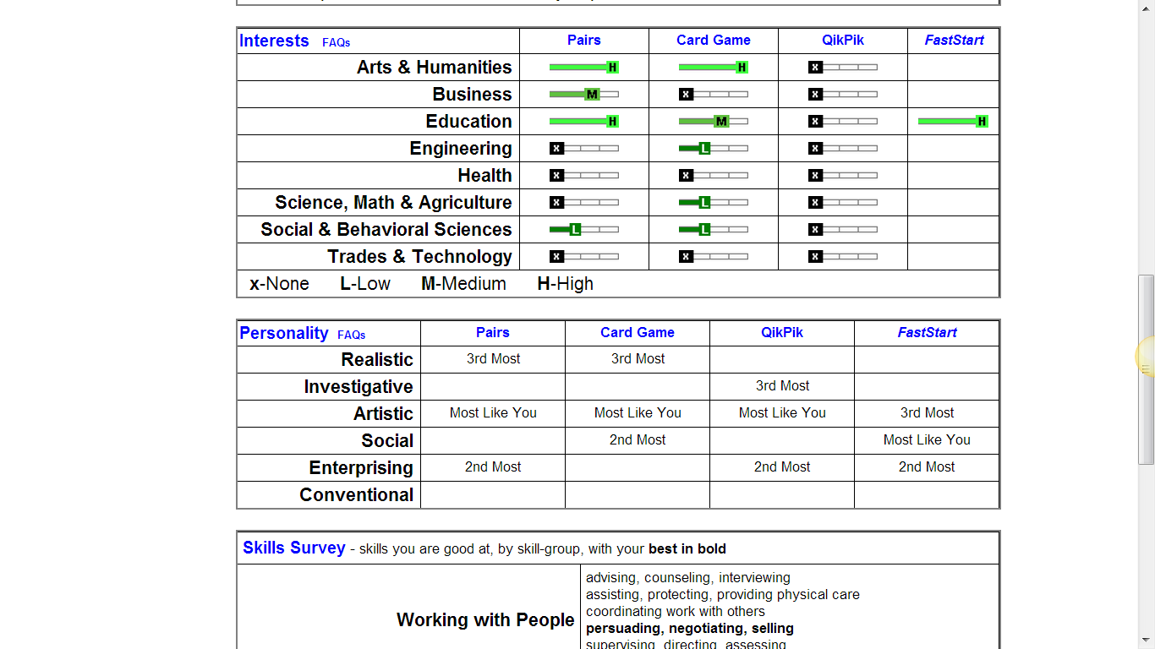
Different
same

