Apps and Websites to Help You Improve
Mindfulness and Reduce Stress

Way of Life

http://itunes.apple.com/us/app/way-of-life/id393159800?mt=8

Description
Way of Life uses a simple system of red and green to monitor both positive and negative trends in your lifestyle

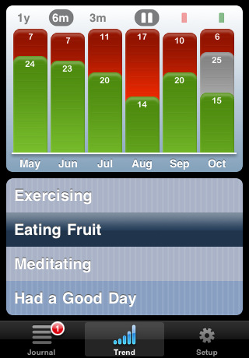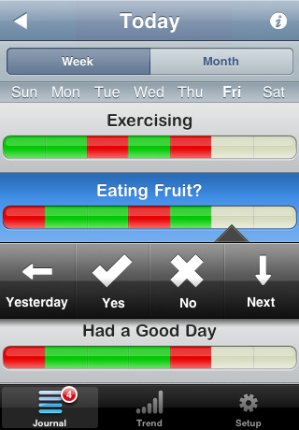
Need to break a bad habit or build a few good ones?
Willing to spend less than a minute daily to do something about it?
Grab Way of Life from the App Store and feel its habit magic change you to who you really want to be...

_______________________________________________________________________________________________________________________________
Stress Check
http://www.androidfreeware.net/download-stresscheck.html

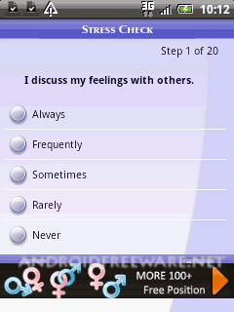
Stress Check assessment is research-based.
Four life domains are analyzed to provide valuable feedback that is tailored to the user

Users can go back to previous questions.
Information is saved if the user wishes

_______________________________________________________________________________________________________________________________

Insight Timer
https://market.android.com/details?id=com.spotlightsix.zentimerlite2&feature=more_from_developer
Insight Timer can help with your meditation practice by allowing you to focus inward, instead of on the clock. Beautiful Tibetan singing bowl sounds will peacefully and serenely guide you through your meditation session.
With the Insight Connect feature, you see at a glance all the people around the world who are meditating with you. Link your Facebook or Twitter account and you and your friends can follow and support one another's practice. You can also make new friends who share your love of meditation.

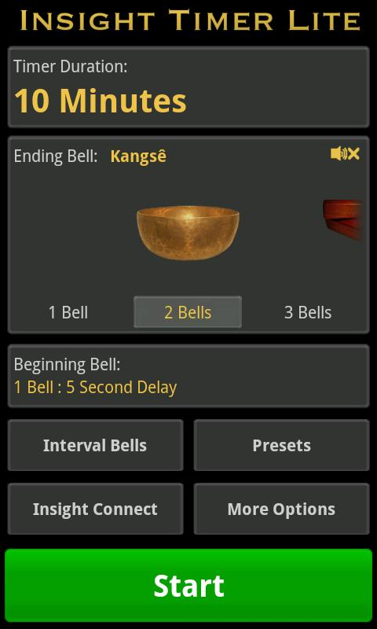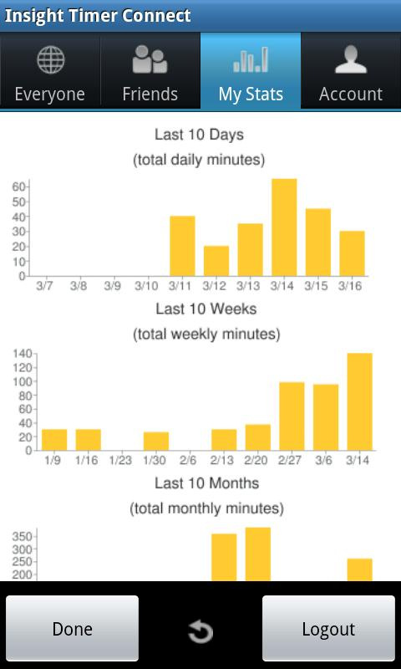

Feel your best at work or in class! Learn 15 stress-relieving moves that you can do at your desk.
Each pose takes less than two minutes and will undo tension in your neck, shoulders, wrists, low back, and hips. So, get up and out of your chair—your body will thank you!

http://www.yogajournal.com/officeyoga/
_____________________________________________________________________________

Nzingha Dalila Performing

10-Minute Mindful Meditation

http://www.uc.edu/content/dam/uc

/counseling/media/Mindful_Meditation.mp3


http://www.mindfulnessdc.org/mindfulclock.html

_____________________________________________________________________________

A Crash Course in Body Scan Meditation

8-Minute Seated Body Scan from NPR

Practice a seated body scan meditation with Trish Magyari. Follow along as she guides a class through the process. (Audio approximately 8 minutes, and contains lengthy pauses.)
http://www.npr.org/templates/story/story.php?storyId=7650123

http://www.amazon.com/Mindfulness-Based-Stress-Reduction-Workbook-ebook/dp/B004G5Z7C6/ ref=dp_kinw_strp_1

