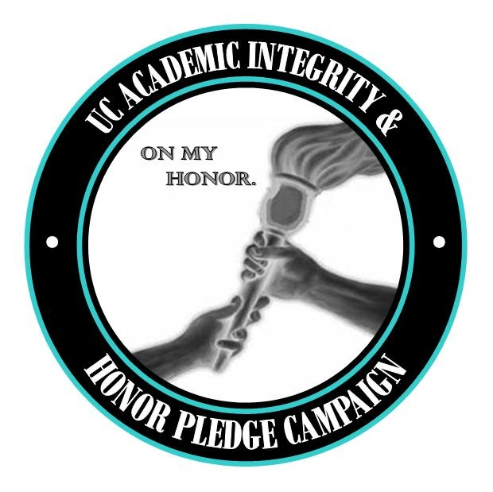 | FREQUENTLY  ASKED  QUESTIONS  On my honor, I pledge that this work of  mine does not violate the U.C. Student Code  of Conduct rules on cheating or plagiarism.

April 27, 2007

In response to questions and objections that have been raised in discussions of the proposed Honor Pledge at meetings of the Faculty Senate, the Deans Council, the Graduate Student Assembly and in the News Record, the Academic Integrity Campaign Committee offers the following responses.

Student Senate acted first at the start of Spring term, unanimously adopting a resolution of support. On April 12 Faculty Senate by voice vote with some opposed endorsed use of a pledge at the discretion of the instructor.

The Student Code of Conduct Review Committee will hold two lunch hour public discussions co-sponsored by Main Street in
TUC Cinema Monday May 7 at noon and Tuesday May 8 at 12:30
seeking university wide feedback on proposed changes to the code that include new language in the section on Academic Misconduct encouraging greater use of an Honor Pledge.

1. Does U.C. have a problem with cheating and plagiarism?

In an unscientific student government poll of U.C. students ending March 7, 2007, 29% of the 6,034 responding indicated they had observed or heard of cheating on campus. Reported cases of cheating and plagiarism by U.C. students increased from 7 in the 2003-2004 academic year to 71 in the 2004-2005 academic year. Examples include term paper plagiarism, copied lab reports, and cheating on tests, including at least one PhD comprehensive exam.

Evidence of widespread cheating elsewhere might be extrapolated to U.C. Of the more than 64,000 undergraduate respondents on a national survey, 11% admitted to copying from another student without their knowledge, 9% with their knowledge, and 10% admitted to helping another student cheat. The 2003 National Survey of Student Engagement (NSSE) found that “87% of college students surveyed reported that their peers sometimes copy and paste information from the Web for reports and papers—without citing sources.” Term paper mills sell work for hire. In a widely publicized recent case, Ohio University has considered revoking MAs awarded to engineering students who were found to have plagiarized their theses.

Faculty as well as students, both at U.C. and other major universities, have violated academic integrity, as illustrated by the Pulitzer prize winning authors found guilty of plagiarism. The recent financial aid loan scandal has also revealed misconduct by administrative staff at the most prestigious institutions. Fabricated degrees on false cv’s are all too common. At a time of pervasive public skepticism about institutional corruption, an honor pledge would be only a first step as U.C. forcefully affirms its commitment to integrity by all members of our community.

2. Does any research show that an Honor Code or Pledge is a meaningful deterrent to cheating?

The Center for Academic Integrity, http://www.academicintegrity.org/, conducts extensive student surveys that provide data used to compare self- reports of cheating at code, modified code and non-code universities. The results of multi-campus surveys with a 35% response rate show a correlation between use of a code or pledge and lower rates of cheating. The methodology is easily challenged, as it is difficult if not impossible to obtain reliable data on the extent of cheating.

CAI Executive Director Tim Dodd notes: “We institute codes and pledges as a call to awareness and understanding and not primarily as a tool of deterrence. While we have responsibility to deter and/or catch those who cheat and plagiarize, we are called by mission to mentor ethical citizens. Codes and pledges, when thoughtfully mobilized throughout students' academic careers, provoke pause, reflection and dialogue -- the hallmarks of the ethically lived life. Deterrence is affected not through coercion or imposition (there are far more coercive and imposing measures that could be adopted if our only concern was to stop cheating) but through a raised consciousness that resists the temptations of expediency and thievery. Codes and pledges teach.”

3. Why adopt an honor pledge that most U.C. faculty will not use or enforce, resulting in even greater cynicism about additional paper work that makes no difference?

An excellent question as illustrated by CAI Assessment Project surveys involving almost 10,000 faculty over a three year period: “44% of those who were aware of student cheating in their course in the last three years, have never reported a student for cheating to the appropriate campus authority. Students suggest that cheating is higher in courses where it is well known that faculty members are likely to ignore cheating.” Our Academic Integrity Campaign seeks to remedy that problem by promoting an honor pledge, and the challenge is indeed a difficult one.

Honor Code systems such as the ones at the UC Colleges of Law and Medicine obligate students to report cheating that they observe. Our proposed honor pledge to be used at the discretion of the instructor does not require students to do so, and it is unlikely that many will take that difficult step. Nor will the pledge deter dishonest students determined to conceal their cheating by falsely signing the pledge. Although the pledge is not a panacea, it can still make a difference. Some students will overcome the temptation to cheat because of the pledge. Some who feel cheated when cheaters gain a competitive edge will be more inclined to report misconduct and to encourage faculty to remedy that inequity. Improved reporting by college conduct officers to the Office of University Judicial Affairs may also result, contributing to improved implementation of the SCOC on campus.

4. What are the consequences for a student who objects to the pledge and does not sign but has not cheated?

Faculty should not award an “F” on an exercise to a student who has honestly done passing work. A proposed change in the SCOC provides that refusal to sign an honor pledge will not be recorded or reported as academic misconduct unless there is evidence of cheating or plagiarism.

Most professors would consider a mandatory, signed affirmation enforced by failure unacceptable, similar to the discredited loyalty oath. U.C. faculty who have used a pledge do so in various ways, and none are known to have failed students for refusing to sign. Science instructors have asked students who wish to use their own electronic devices on a test to sign a statement that no unauthorized material is stored on their equipment. Those who refuse were only allowed to use calculators supplied by the department. In lab courses, students required to complete an ethics pre-test have been found less likely to cheat. The faculty co-chair of the pledge campaign provides an anonymous paper ballot to measure student support before using a pledge on tests. Varying the wording of the pledge used or asking students to write out the pledge instead of signing a printed statement are possible ways to avoid ritualized recitation of an affirmation that has diminishing returns.

Instructors already have the academic freedom to adopt a great range of sanctions for excessive absence, cheating, or refusal to sign a pledge that they require. Some instructors are far more punitive than others. Students can challenge an unduly harsh sanction as arbitrary and have the right to a grievance hearing that can result in a lighter penalty.

CAI Executive Director Tim Dodd writes: “Faculty can address students who refuse to sign pledges in one of two ways. Many refuse to accept and grade work submitted without a signed pledge. Others encourage students to write their own statements about how their execution of the test or assignment comports with the values of academic integrity and ethical conduct. . . . I strongly endorse the latter approach. . . . I would advocate for students to be given a choice between signing the adopted pledge or crafting their own statements in classes in which an instructor requires a pledge. We have had instances here at Duke of students writing whole pages justifying their methods and/or anguishing about their uncertainties. A valuable learning exercise. . . . If our goal is to provoke pause and reflection, let students spend some time reflecting on the values of open and honest scholarship as they apply to particular exams, labs and papers.”

5. Where can I find more information and/or challenge these answers?

Check out the Academic Integrity Campaign list of references at http://www.uc.edu/conduct/Academic_Integrity_Campaign.html

Committee Co-chairs
Daniel.Cummins@uc.edu, Director Office of University Judicial Affairs or
Howard.Tolley@uc.edu, Professor of Political Science.

Committee Members: Pam Bach – Librarian, Holly Barber - Student Government, Billie Burton - Asst. Dean A & S, Michelle Conroy - Student Government, Dr. John Ned Donnelly - Educational Services, Dr. Regina Sapona - Asst. Dean CECH, James Radley -- Student Body President

Based on “Cheating Among College and University Students: A North American Perspective,” International Journal for Academic Integrity (2005) Volume 1, No. 1. (http://www.ojs.unisa.edu.au/journals/index.php/IJES/article/viewFile/14/64) and the author Don McCabe’s powerpoint presentation at the 2001 meeting of the Center for Academic Integrity.
NSSE: Vast majority of undergrads using IT, but ‘cut-and-paste’ a typical academic ‘strategy’ December 12, 2003 http://homepages.indiana.edu/121203/text/technology.shtml
From “Some Good News about Academic Integrity,” Change (2000) 32, No. 5, 32-38. (with G. Pavela) http://www.findarticles.com/p/articles/mi_m1254/is_5_32/ai_66278484/pg_7 "What We Know About Cheating in College: Longitudinal Trends and Recent Developments," Change (1996) 28, No. 1, 28-33 (with L.K. Trevino). http://www.findarticles.com/p/articles/mi_m1254/is_n1_v28/ai_18011556/pg_4 The author Don McCabe’s powerpoint presentation at the 2001 meeting of the Center for Academic Integrity based on survey responses from a 1995 survey of over 4,000 students at 17 code and 14 non-code schools reports self reported test cheating of 30% and 45%. Twice as many women as men responded to the survey leading him to caution about use of the results. His 1999 research based on over 2,000 responses included several “Modified Code” schools that used an honor pledge – University of Maryland, Kansas State, and University of California at Davis -- where the 36% reported rate of cheating was higher than at code schools, but below the 45% rate at non-code universities.

