Running a Pre-Health “What-If” Report in Catalyst
Want to look at the progress you are making on a Pre-Professional health track? Pre-Professional Advising has a “What-If” audit that you can access through Catalyst to help you track courses, cumulative and science GPAs. It is similar to a Degree Audit that you run for your major.
Getting Started:
- Go to catalyst.uc.edu and log in with your 6+2 and password.
- Choose “Run a What- If” Report from your My Academics Page. 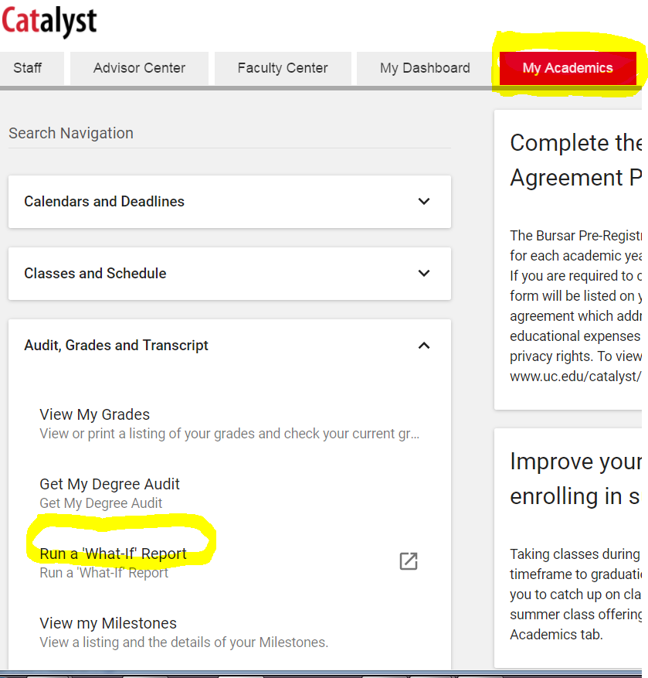
- Click on “Create Report.”
- Choose “Program Scenario.” Click on the “Academic Program” box and find Pre-Professional Advising from the drop down list (tip: click “P” on your keyboard to find quickly). Then, choose “Area of Study” and the list will include the following Pre-Professional programs: Chiropractic, Medicine, Physician Assistant, Dentistry, Optometry, Podiatry and Veterinary.
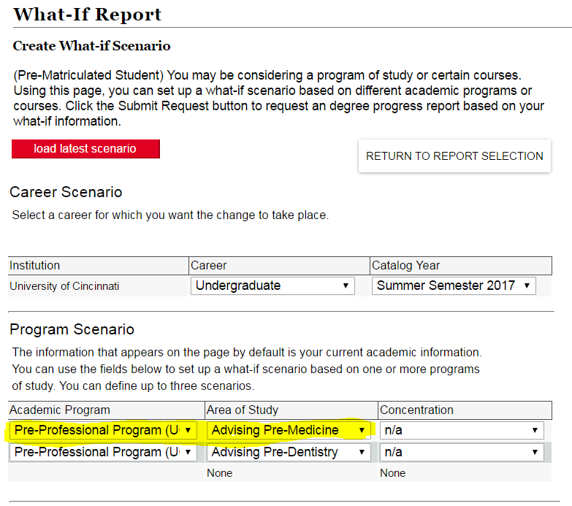
- Once chosen, click submit and wait for the report.
The report is a good way to see the courses/grades you have completed and see your science/math GPA. Be sure to then talk with your Pre-Professional Advisor to make sure you are balancing your academic and non-academic application experiences. (For appointments contact us at 513-556-2166 or preproadv@uc.edu ). Updated: 6-2017

