Forming a Club Sport Information Packet
Students wanting to start a new UC club sport recognized student organization should take the following steps:
• The organization must fill a need for students not currently being met by an existing organization on campus.
• Register your new organization on Campus LINK (www.campuslink.uc.edu). You will be asked for the following information as part of the registration process online.
- Upload Constitution and Bylaws consistent with University policies. A sample is provided in the next section of this manual.
- Complete a registration application. Invite group officers and advisor to your group. You will need their UC username (6+2).
  - As part of your roster you must have
    - At least ten (10) University students as members in good standing with the university (2.0 GPA, full-time student) on your Campus LINK site’s roster
    - A University advisor who is a member of the University faculty, staff, or administration
- For club sports organizations: Upload a risk management plan for your club sport organization. Providing risk reduction measures for your club and answering the questions provided in the outline.
• Student Activities Board (SAB) will review your new student organization application and respond to you. All requests for new student organizations to be recognized during the academic year should be made by March 1st.

Following approval from the Student Activities Board (SAB), program and department rules will bind the club sport to the club sports regulations regarding travel, funding, and operations. New clubs must spend one year as conditional status to demonstrate stability in terms of attracting campus-wide participation annually. This means clubs, in their first year, must be virtually financially self-supporting (club sports teams cannot collect funds from the University Funding Board at any point).
To first register your organization, once you have the items above go to UC Campus LINK and click on Organizations. From the Organizations page click “Register a New Organization”. You will need officers’ and your advisor’s UC usernames (6+2). Here is a link to the page.
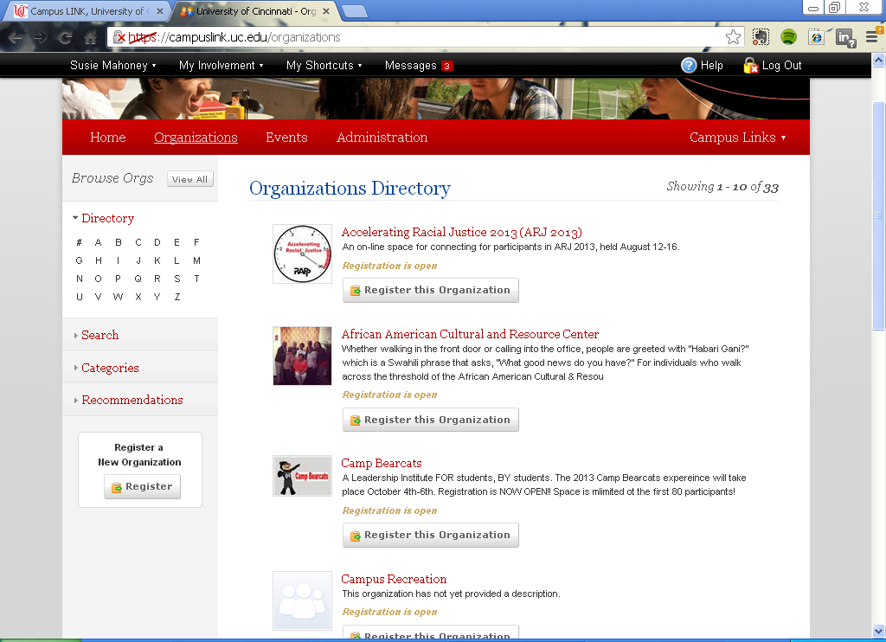
The Club Sports Handbook should serve as a great resource to you. Check out the links on the Club Resource page. To learn more about Campus LINK and how to use the organization’s tools, head to the following site and if possible attend a SAB Campus LINK workshop or schedule a meeting with the Club Sports Program Coordinator at susan.mahoney@uc.edu.
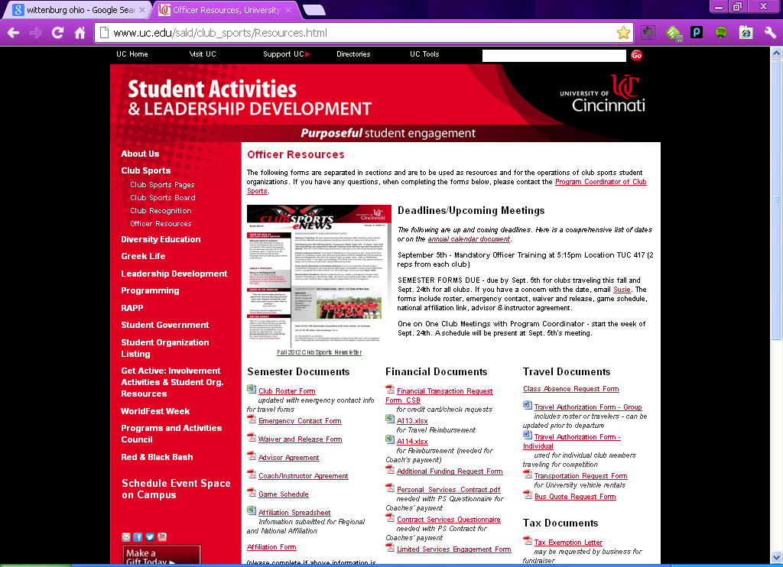
Other considerations:
- Who would we play? Check to see if there are any local leagues or any other clubs that you could play in the Greater Cincinnati Area (Miami of OH, University of Dayton, NKU, Xavier, and Wright State University). The Program Coordinator of Club Sports can assist with this.
- Without funding our first year, what would are budget look like? See sample below.
- Should we inquire about a coach?
- Recruitment – see if there are any club events and/or any opportunities to place flyers around campus in Res Halls and through TUC/Mainstreet.
Budget
Here is a sample yearly budget of a newer club sport organization that estimated for 3-4 games.
Sample Club Sport First and Second Year Budgets
Revenue
 | Amount for Current Fiscal Year (11-12) | Anticipated Amount for Next Fiscal Year (12-13) | Difference
Membership Dues | $80 x 17 Members = 1360 | $ 1,360.00 | $ -
Fines |  |  | $ -
Alumni Donations |  |  | $ -
Corporate Donations |  |  | $ -
Fundraising Projects |  |  | $ -
 |  |  | 0
Expenditures
Administrative | Amount for Current Fiscal Year | Anticipated Amount for Next Fiscal Year | Difference
Association Fees (local, regional, national, etc.) | $ 615.00 | $ 700.00 | $ (85.00)
Printing |  |  | $ -
Postage |  |  | $ -
Advertising |  |  | $ -
Website Domain Fees |  |  | $ -
Referee costs |  |  | $ -
Coach(es) Salary |  |  | $ -
 | $ 615.00 | $ 700.00 | $ (85.00)
Travel | Amount for Current Fiscal Year | Anticipated Amount for Next Fiscal Year | Difference
Registration Fees | $ 200.00 | $ 200.00 | $ -
Transportation Services (University Vehicles) | $180 | $550 | $ -
Other Vehicle Rental (Charter buses) |  | (for 3-4 trips) | $ -
Airline Tickets |  |  | $ -
Gas associated with University Vehicles | $100 | $150 | $ -
Other Gas |  |  | $ -
Lodging | $419 for one overnight | $1,000 | $ (81.00)
Miscellaneous Travel Costs |  |  | $ -
 | $ 899.00 | $ 1,900.00 | $ (81.00)
Equipment | Amount for Current Fiscal Year | Anticipated Amount for Next Fiscal Year | Difference
Uniforms (split cost between 2 years) | $25/uniform x 20 | $25/uniform x 20 | $ -
non-reusable clothing (socks, gloves, shoes, mouth guards, etc.) |  | (individual players purchase and keep jersey) | $ -
Other clothing |  |  | $ -
Facilities rental |  |  | $ -
Equipment |  |  | $ -
non-reusable equipment (pucks, paint pellets, etc.) |  |  | $ -
Equipment Rental/Lease |  | $300 - need goals (2) | $ (300.00)
 | $ - | $ 300.00 | $ (300.00)
 |  | $500.00 | for Jerseys
Total Expenditures | $ 1,514.00 | $ 1,680.00 | $ (166.00)
 |  | 2180 with Jerseys

Sample Constitution and Bylaws
On the Club Sports Officers Resource page there is a sample constitution and bylaws to follow and a checklist of what should be included in both documents. Below is a well put together constitution and bylaws for one of our current clubs. This was recently completed by one of our newer clubs.

Bylaws of the University of Cincinnati Women’s Rugby Football Club
SECTION 1 - STUDENT OFFICERS
1(1) The President shall be the Executive Officer of the University of Cincinnati Women’s Rugby Football Club and shall preside over all meetings of University of Cincinnati Women’s Rugby Football Club and the Executive Board. He/she shall be an ex-officio member of all standing committees.

1(2) The Vice-President, in the absence of the President shall preside at all meetings of the student organization and of the executive board. The Vice-President shall also perform such other duties as are assigned to him/her by the President of the Executive Board. The Vice-President is also responsible for the ordering of the uniforms as well as any other item that is to be ordered that is considered part of a rugger’s kit.

1(3) The Treasurer shall be responsible in conjunction with the University advisor, to all fiscal matters of the student organization.
- The Treasurer shall collect and receive all funds paid to the student organization and shall deposit them in the official depository.

(b) The Treasurer, in conjunction with the University Advisor and President, will have final approval of all student organization expenditures. The Treasurer will co-sign all checks with the University Advisor in payment of bills.
(c) The Treasurer will abide by all policies and guidelines set down by their respective funding board (Club Sports Board).
(d) The Treasurer is responsible for educating his/her successor on the obligations of this position.
(e) The Treasurer will keep the accounts and books which, at all times, must be open to inspection by the President, Executive Board, Club Sports Board, SALD Club Advisor, or any authorized auditor.
(f) The Treasurer will make reports at the semesterly meetings of the University of Cincinnati Women’s Rugby Football Club and at other such times as the President or Executive Board may direct.
(g) Failure to abide by these aforesaid policies will result in financial probation of the University of Cincinnati Women’s Rugby Football Club as defined by their respective funding board.
1(4) The Match Secretary shall keep the records of the membership and the minutes of the meetings of the University of Cincinnati Women’s Rugby Football Club and the Executive Board. He/she shall make a report at the annual meeting of the University of Cincinnati Women’s Rugby Football Club and at such time as the President or the Executive Board may direct.

1(5) The Transportation Secretary shall be in charge of renting any required vehicles for away games through the appropriate channels of the University of Cincinnati.

1(6) The Field Chair shall be in charge of the upkeep of all equipment that belongs to the club, these items include jerseys, balls, and other items that are bought with team money to be used by the team.

1(7) The Social Chair shall be in charge of recruiting new players. Any recruiting methods or ideas must be approved by the Executive Board.

SECTION 2 - ELECTIONS
2(1) Elections will be held at the end of formal practice in the Fall.

2(2) All officers shall be elected by a majority vote of those persons casting ballots.
2(3) Officers will take office the first of the year as in accordance with the Ohio Rugby Union.

SECTION 3 - EXECUTIVE BOARD
3(1) The Executive Board shall be composed of the President, Vice-President, Match Secretary, and Treasurer of the University of Cincinnati Women’s Rugby Football Club.

3(2) The Executive Board shall determine the policies and the activities of the student organization, discipline members, approve the budget, and have general management of the University of Cincinnati Women’s Rugby Football Club.
3(3) The Executive Board shall meet regularly at least once a month and at the call of the President.

SECTION 4 - UNIVERSITY ADVISOR
4(1) The University Advisor shall consult with the University of Cincinnati Women’s Rugby Football Club and ensure that the activities of the University of Cincinnati Women’s Rugby Football Club are consistent with the stated purposes of the organization.

4(2) The University Advisor is required to attend an Advisor Training sponsored by the Office of Student Activities and Leadership Development every two years.
4(3) The University Advisor has an obligation to know the rules and regulations governing the handling of all funds and to assist and advise the treasurer in all financial matters and to co-sign checks.

SECTION 5 - SPECIAL COMMITTEES
5(1) Special Committees may be established by the Executive Board and shall perform such duties as defined in their establishment.

5(2) The Executive Board shall appoint, and may remove, committee members and a Chairperson for each committee.

SECTION 6 - MEETINGS
6(1) Meetings shall be held at such places as determined by the President.

6(2) The semesterly meetings of the University of Cincinnati Women’s Rugby Football Club shall be given at least two weeks notice of the place of the semesterly meeting.
6(3) At all meetings designated as important, a quorum shall be a minimum of one senior member back and one senior member forward as defined by their positions on the playing field. A quorum is necessary for the organization to conduct official business.
6(4) All matters coming before the University of Cincinnati Women’s Rugby Football Club which require the approval of the membership, and the election of officers, shall be carried by the majority vote of the voting members present, providing that a quorum is present, except for business specified in the constitution or bylaws which require a specific number, i.e., ratification, etc.

SECTION 7 - REVENUE
7(1) A membership fee of $10 shall be paid to Treasurer of the Student Organization prior to participation in the first game of the season.

7(2) The annual dues shall be $50 per season, both Fall and Spring.
7(3) Registered student organizations can generate revenue from sources (fundraisers, bake sales) other than those defined in this section as determined by the student organization’s advisor, executive board, and University of Cincinnati Women’s Rugby Football Club. The funds generated through fundraising must be used to further the student group’s mission, programmatic efforts, or their support of philanthropic efforts (i.e. Relay for Life).
7(4) The disbursement of said revenue shall be determined by the Executive Board.
7(5) The Treasurer shall be responsible for the accountability of the Student Organization's monies, and shall report to the Executive Board and the Student Organization.

SECTION 8 - DISCIPLINE
8(1) Any member being two months in arrears in the payment of dues shall stand suspended and shall be notified immediately, in writing, by the Treasurer. Such member, upon payment, and upon making application for reinstatement to the Executive Board within thirty (30) days of such notice may be reinstated by three-fourths (3/4) vote of the entire Executive Board. In the event such member is not reinstated he/she shall be dropped from membership and shall be notified, in writing by the Secretary

8 (2) Any member charged with conduct not in accord with the purposes of the University of Cincinnati Women’s Rugby Football Club and against who such charges are sustained after due and proper hearing before the Executive Board, may be expelled from membership by a three-fourths (3/4) vote of the entire Executive Board
8(3) Any student whose membership the University of Cincinnati Women’s Rugby Football Club has been terminated in any manner shall forfeit all interest in any funds or other property belonging to the University of Cincinnati Women’s Rugby Football Club and may not use the organization's name in connection with any further activities.
8(4) Appeal process: Any member whose membership in the University of Cincinnati Women’s Rugby Football Club has been terminated by action of the Executive Board of the organization may appeal his/her expulsion, in writing, and within two weeks of the Executive Board's action to the University of Cincinnati Women’s Rugby Football Club 's respective governing board If the expulsion is upheld by the governing board, the student may appeal to the Student Organizations and Activities Office in writing, and within two weeks of the governing board's action.

SECTION 9 - IMPEACHMENT
9(1) Petition Executive Board with signatures of 1/2 of all voting members petition should state reason for removal.

9(2) Executive Board shall then notify officers and call for removal vote within fourteen days of the filing of the petition.
9(3) Membership shall be notified at least one week prior to removal vote meeting.
9(4) At the meeting for removal, the petition's stated grievances shall be made public and the officer charged shall be allowed to respond to the charges of the petition.
9(5) Removal from office shall require a vote of 2/3 of all voting members present at the meeting.

SECTION 10 - VACANCY OF OFFICE
10(1) In case of resignation or removal of any officer, an interim acting officer shall be appointed by the Executive Board.
10(2) The President shall call for an election within fourteen days after vacancy of any office.
10(3) Election shall be conducted as stated in the bylaws.
10(4) Should the office of President become vacant, the Vice-President should complete the President's unexpired term and call for an election for Vice-President consistent with the provisions of Section 10(2).

SECTION 11 - RULES OF ORDER
"Robert's Rules of Order, Revised'' shall be the parliamentary authority for all matters of procedure not specifically covered by these by-laws.

SECTION 12 - AMENDMENTS OF BYLAWS
12 (1) Amendments to these Bylaws may be proposed by any member and shall be voted upon at the next meeting of the Student Organization following notice of such proposed amendment to the voting members, such notice shall be given within one week of the time any such amendment is proposed.

12 (2) Amendments to these Bylaws shall be by the affirmative vote of one-half (l/2) of all voting members and with the approval of the appropriate governing board.

SECTION 13 – DISSOLUTION
13 (1) Upon the dissolution of the University of Cincinnati Women’s Rugby Club for any reason, all work, funds, and property controlled by the organization will be transferred to the University of Cincinnati or to an organization that models the organization’s purpose.

13 (2) The Advisor and executive officers of the student organization will oversee the dissolution process.

SECTION 14 – NON-HAZING CLAUSE
14 (1) The laws of the state of Ohio and the University of Cincinnati policies concerning hazing shall be observed.
14 (2) Hazing shall be defined as participating in or allowing any act or coercing another, including the victim, to do any act that creates a substantial risk of causing mental or physical harm to any person. A forced or coerced activity shall also be considered hazing when the initiation or administration into, or continued affiliation with, a university organization is directly or indirectly conditional upon performing the activity. In no event shall the willingness of an individual to participate in such an activity serve as defense in cases of hazing.
14 (3) Actions and activities, which are explicitly prohibited, include, but shall not be limited to the following:
a. Any activity that creates a substantial risk of physical or mental harm.
b. Paddling, beating, or hitting individuals.
c. Wearing anything designed to be degrading or to cause discomfort.
d. Depriving individuals of the opportunity to obtain a minimum of six hours of sleep per day, proper and adequate means, or access to means, of maintaining body cleanliness.
e. Activities that interfere with an individual’s academic efforts by causing exhaustion of loss of reasonable study time.
CONSTITUTION OF THE UNIVERSITY OF CINCINNATI
WOMEN’S RUGBY FOOTBALL CLUB

ARTICLE I- NAME
University of Cincinnati Women’s Rugby Football Club

ARTICLE II- PURPOSE
The purpose of the University of Cincinnati Women’s Rugby Football Club is to promote the sport of rugby at the University of Cincinnati through active competition.

ARTICLE III- MEMBERSHIP
3.1 There shall be two (2) classes of members; voting and non-voting.
3.2 Voting membership shall be open to any full/part-time graduate and undergraduate students enrolled in any of the colleges, schools, or divisions of the University of Cincinnati at the time of applying for membership and is sincerely interested in the sport of rugby football.
3.3 Non-voting membership shall be open to any student, and any member of the University faculty or administrative staff.
3.4 There shall be no limit on the size of the University of Cincinnati Women’s Rugby Football Club, provided, however, that the number of the non-voting and honorary members together, shall not exceed the number of voting members.
3.5 This organization shall not discriminate on the basis of race, color, ethnicity, national origin, age, gender, disability or handicap, religion, sexual orientation, disabled veteran’s status or veteran status in any of its policies, procedures, and practices. This policy will include but is not limited to recruiting, membership, organization activities, or opportunity to hold office.

ARTICLE IV- OFFICERS
4.1 The officers of the University of Cincinnati Women’s Rugby Football Club shall be a President, Vice President, Match Secretary, and Treasurer.

4.2 (1) In order to run for office in your respective organization you must have a 2.3 or above accumulative GPA. (2) While in office the officer must maintain a 2.3 a cumulative GPA and must not have below 2.3 for more than one semester. (3) Officer must be a matriculated student and be in good standing with his or her college.
4.3 All officers serve for a term of one year or until their successors shall be duly elected and qualified.
4.4 Any officer who, during the term of his/her office, ceases to be a voting member, or fails to maintain his/ her status as a matriculating undergraduate/graduate (exception University organizations) student maintaining a 2.0 accumulative GPA, in good academic and disciplinary standing with their respective college, shall be removed from his/her office and a replacement shall he elected.

ARTICLE V- MEETINGS
5.1 Regular meetings of the University of Cincinnati Women’s Rugby Football Club shall he held at a minimum of once per semester, the time for such meetings shall be determined by the Executive Board, with the approval of the voting members.

5.2 Special meetings of University of Cincinnati Women’s Rugby Football Club may be called at any time by the Executive Board upon one week's notice to each member or by a petition of a majority of the membership, submitted one week before the scheduled meeting.

ARTICLE VI- UNIVERSITY ADVISOR
The University of Cincinnati Women’s Rugby Football Club shall have a University Advisor who shall be a full- or part-time member of the University faculty, staff, or administration. The University Advisor shall be selected by the Executive Board.

ARTICLE. VII- AMENDMENTS
7.1 Amendments to this Constitution may be proposed by a member and shall be voted upon at the next meeting of the University of Cincinnati Women’s Rugby Football Club following notice of such proposed amendment to the voting members, such notice shall be given within one week of the time any such amendment is proposed.

7.2 Amendments to this Constitution shall be the affirmative vote of two- thirds (2/3) of all voting members and with the approval of the appropriate governing board.

ARTICLE VIII- RATIFICATION
Ratification by two-thirds (2/3) of the charter members of the University of Cincinnati Women’s Rugby Football Club shall be sufficient to establish this constitution between said members so ratifying and with the approval of the appropriate governing board.

