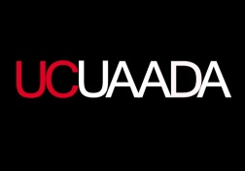

2014 SARAH GRANT BARBER OUTSTANDING ADVISING AWARD
NOMINATION FORM
Complete this nomination form, compile support documents and return to Jennifer Lewis no later than Monday, 07 April 2014 by 8am.
Nominations are accepted via email: jennifer.lewis@uc.edu or sent to 105 Lindner Hall ML0020.

NOMINEE

__________________________________________
Name of Nominee

__________________________________________
Title

__________________________________________
College/Department

__________________________________________
Phone

__________________________________________
E-mail

NOMINATOR

__________________________________________
Name of Nominator

__________________________________________
Title

__________________________________________
College/Department

__________________________________________
Phone

__________________________________________
E-mail

__________________________________________
Nominator Signature

I agree to have my nomination letter read by the nominee after the selection process. (The answer does not impact the committee’s decision or the nominee’s eligibility to receive an award.) Yes No

In the event that this nominee is chosen for the award, please notify the following individuals (e.g., supervisors, deans, etc.) in addition to the nominators.

__________________________________________
Name

__________________________________________
Title

__________________________________________
Email address

__________________________________________
Name

__________________________________________
Title

__________________________________________
Email address

