C-Ring Award Application

The C-Ring award is given each spring to an outstanding graduating senior woman at UC. First given in 1922 by the Athletics Department to the best "all around gal," the C-Ring has evolved over the last 90-plus years to become an all-university award honoring demonstrated commitment to the betterment of the UC campus, community and the advancement of women and girls.

For additional information regarding the C-Ring Award, please contact
Ann Brown at 513-556-4401.

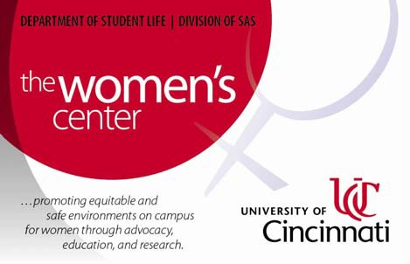Directions: Complete the following information on the form below. Return completed form with: Letter of
Support, Personal Essay, and Resume to Ann Brown via email browam@uc.edu. Completed Application
Packets are due by 5:00pm Friday January 24, 2014.

Name of Applicant: M Number:
Local Address:

City: State: Zip code: Phone:

………………………………………………………………………………………………

Permanent Address:

City: State: Zip code: Phone:

Phone Number: Cell Phone Number: Email Address:
……………………………………………………………………………………………... College: Major:

When will/did you graduate:

Cumulative Grade Point Average (University):

………………………………………………………………………………………………

The annual “C-Ring Award Dinner: A Celebration of UC Women’s Leadership” will be held in the Stratford
Banquet Hall on Saturday, April 5, 2014, 6:00pm. All C-Ring finalists will be honored and the 2013-2014
C-Ring recipient will be announced at that time.

If you are selected as a finalist, will you be attending? Yes No

UC Women’s Center 2014 C-Ring Award Application Form Item 1 of 4 in Application Packet

