C-Ring Award Letter of Support

The C-Ring award is given each spring to an outstanding graduating senior woman at UC. First given in 1922 by the Athletics Department to the best "all around gal," the C-Ring has evolved over the last 90-plus years to become an all-university award honoring demonstrated commitment to the betterment of the UC campus, community and the advancement of women and girls.

For additional information regarding the C-Ring Award, please contact
Ann Brown at 513-556-4401.

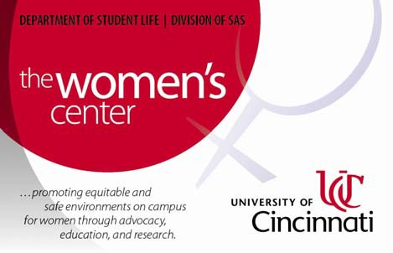Directions: Complete the form below and attach to the Letter of Support. Please email your completed Letter of Support with form to Ann Brown at browam@uc.edu by Friday, January 24, 2014,5:00 pm. Late letters will not be accepted.

Nominee’s Information

Name: College: Major:
Supporter’s Contact Information

Name: Status (circle): Faculty Staff Alumnus

Title: Department: M.L.
Phone Number:

Relationship to Nominee
Briefly describe your relationship to the nominee (cannot be a family member):

Letter of Support Prompt

In your letter, please address how the student has demonstrated advocacy for women.
Be as specific as possible and limit your response to two pages. Examples of advocacy for women/girls from former C-Ring recipients can be found at www.uc.edu/ucwc/we/C-Ring/apply.

UC Women’s Center 2014 C-Ring Letter of Support Item 2 of 4 in Application Packet

