Ally Institutional Report Instructions

Ally for Canvas has some new reporting features that are now available. Below are instructions for accessing the Ally Institutional Report for those with college/school/department level administrator access in Canvas.

This report will allow you to see a dashboard that contains a summary of scores, accessibility issues, and file types for all courses you have administrator permissions for and will allow you to export an Ally institutional report in Excel that outlines all scores/issue counts for each course your administrative permissions give you access for. For more information about what is included in the exported report, see the Ally Institutional Reports Exports for Instructure Canvas resource.

Steps for Accessing This Information

- Log in to Canvas using your administrator login.

- Select Admin on the Left side menu and then select your college/school/department level access.

- Select the Ally Institutional Report.

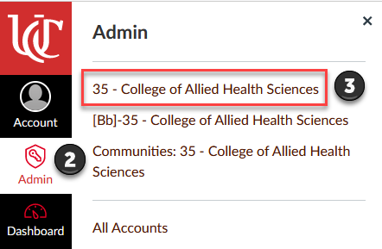

The Ally Institutional Report automatically opens in the Overview tab. Overview shows a comprehensive overview of the courses you have administrator access to (e.g., all college courses). For all courses listed, it shows the average accessibility score progress over time, information about the types of content created, and accessibility issues by severity. The information shown in the screen shot is for Fall 21 term. You can review this information by academic year, term, or month.

You can also export the data to a zip file of CSV files for further analysis. If you export the report, it contains all courses/terms, so you will need to sort the spreadsheet by the term or other parameters you are looking for.

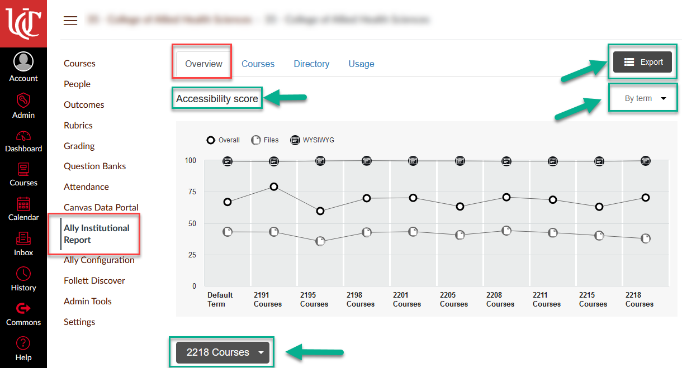

Content types are found in the center dial. You can select the term you would like to see information on by using the dropdown.

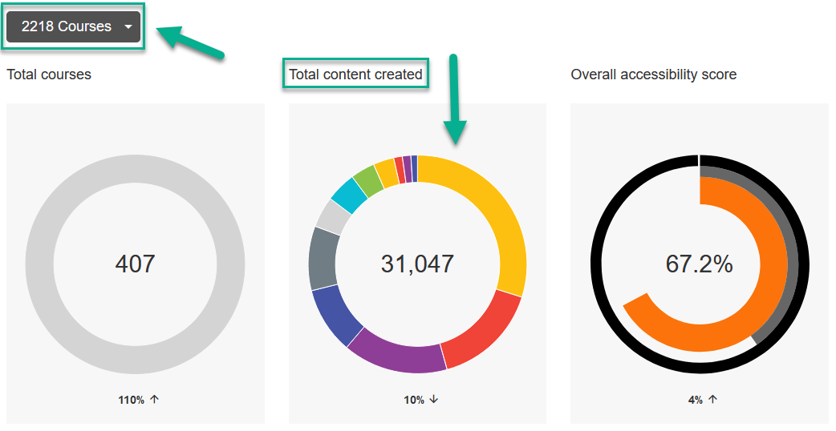
Accessibility issues are listed by issue type and can be sorted by severity. You can drill down on a specific issue by selecting the issue (hover over the issue to highlight it and then click on it) or by clicking the arrow on the far right.

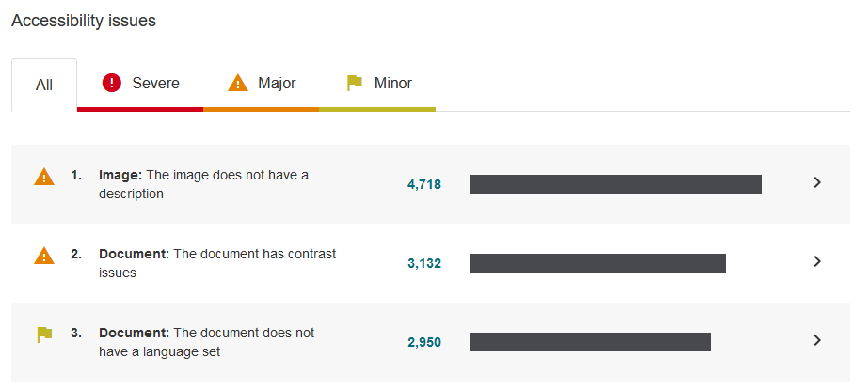

- On the courses tab, you can search for a specific course or browse through the list of courses and click the course link. Each course listed will tell you the number of students enrolled, the number of items in the course, and the current accessibility score for that course.

Once you select a course, you can see a course specific dashboard that offers the same information as the main report screen, but specific to that course. You can also export a course report, see the file content of the course, and drill down on specific accessibility issues in that course just like you would from the main screen.

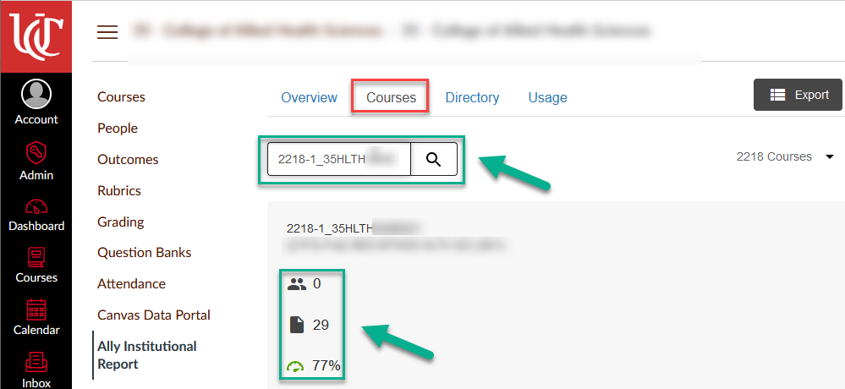

- On the Directory tab, you can review program specific data and reports. The report shows the number of courses, number of items analyzed, and the overall program accessibility score. You can click the View Report button for a specific program review accessibility information for all courses in that program. This tab allows you to export the reports for specific programs within your college/school (depending on your permissions).

