Guest Reimbursements Guide

This guide details the different situations in which a guest is reimbursed by UC, including who is considered a guest, and the appropriate process to follow based on each situation.
Contents
Guest Reimbursements Guide 1
Guest Details 1
Guest with a Concur Profile 1
Guest with a Vendor ID but Without a Concur Profile 2
Reimbursing a Guest with a Vendor ID but no Concur Profile 2
Non-Profiled, No-Vendor-ID Guests 3
Reimbursing a Guest without a Vendor ID nor a Concur Profile 3

Guest Details
The following types of person are considered a guest in Concur:
- Adjunct faculty
- Affiliated staff
- Board of Trustees members
- Consultants
- Contractors
- Emeriti faculty
- Recruits (student and employee)
- Speakers
- Student workers (e.g. graduate assistants)
- Visitors

Guest with a Concur Profile
If someone in one of the above categories is reimbursed regularly (>5 times/year), it may be best to set them up with a manually created Concur profile so that they can log in and create their own travel requests and bookings and expense reports. To request a profile, submit a CONCUR GUEST PROFILE REQUEST FORM.
Once the guest has a Concur profile, they should log in and follow the standard processes for creating travel bookings, requests, and expense reports.
If another user wishes to handle the process for them, they must be made a delegate for the user. As a delegate, they must act on behalf of the user’s profile. Delegates cannot submit an expense report, and the user will need to log in for the final review and submission.

Guest with a Vendor ID but Without a Concur Profile
Guests in some of the above categories may have a vendor ID already set up because of their employment, though they lack a Concur profile, and those that do not can have one created by Accounts Payable if they are reimbursed regularly (>5 times/year). The existence of a vendor ID allows another user to submit an expense report to reimburse the guest without having to enter all their payment details on every expense report. These guests do not have Concur access.
To confirm a guest’s current vendor ID number or to have one created, please contact Accounts Payable.

Reimbursing a Guest with a Vendor ID but no Concur Profile
- Create a new expense report
- In the Policy field, select “*UC-Guest Expense Policy”
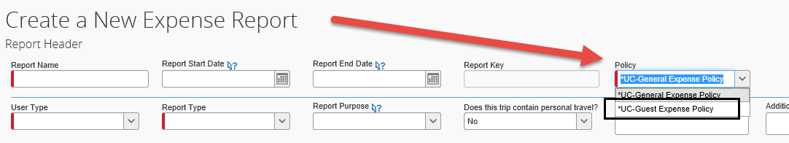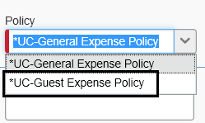
- In the Report Purpose field, select “Non-Profiled Guest/Paper TA” if the trip involved at least one overnight stay or “Mileage, Non-overnight or Local” if the guest’s visit was non-overnight
- In the “Does the traveler have an A.P. Vendor ID? Field, select “Yes”
- In the “Guest Vendor list” field, find and select the guest’s vendor ID
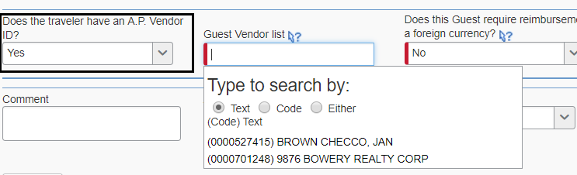
- Complete the remaining Report Header fields and click Next
- To the question “Are you receiving Per Diem for Meals on this trip?” click No
  - To reimburse guests for per diem, an expense must be manually added to the expense report under the expense type “Guest Daily Per Diem”
  - The user will need to enter the GSA per diem rate as applicable
- Attach the paper travel authorization for the guest’s trip by clicking Receipts > Attach Receipt Images
- Once all of the expenses have been added to the report, click Submit to send it for approval. Once approved, payment will be issued to the guest
Please note: If the traveler requires payment in a foreign currency, please contact Accounts Payable. When completing the Report Header, in the “Does this Guest require reimbursement in a foreign currency?” field, select “Yes” and enter the type of currency in the “Reimbursement Currency” field. The user will also need to attach a completed Wire Form to the report in order to complete the foreign currency payment.

Non-Profiled, No-Vendor-ID Guests
Guests without a vendor ID or Concur profile must have their payment details entered on the expense report by the UC user processing an expense report for the guest’s reimbursement. The guest has no access to Concur, and they will only be reimbursed once or infrequently (<5 times/year).

Reimbursing a Guest without a Vendor ID nor a Concur Profile
- Create a new expense report
- In the Policy field, select “*UC-Guest Expense Policy”
- In the Report Purpose field, select “Non-Profiled Guest/Paper TA” if the trip involved at least one overnight stay or “Mileage, Non-overnight or Local” if the guest’s visit was non-overnight
- In the “Does the traveler have an A.P. Vendor ID? Field, select “No”
- Complete the following guest details fields: “Name of the person to reimburse,” (please enter Last Name, First Name of the guest), “Address 1,” “Address2” (if applicable), “City,” “State,” and “Zip”
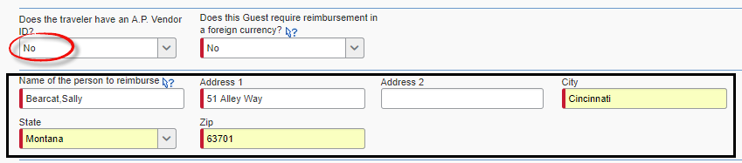
- Complete the remaining Report Header fields and click Next
- To the question “Are you receiving Per Diem for Meals on this trip?” click No
  - To reimburse guests for per diem, an expense must be manually added to the expense report under the expense type “Guest Daily Per Diem”
  - The user will need to enter the GSA per diem rate as applicable
- Attach the paper travel authorization for the guest’s trip by clicking Receipts > Attach Receipt Images
- Once all of the expenses have been added to the report, click Submit to send it for approval. Once approved, payment will be issued to the guest
Please note: If the traveler requires payment in a foreign currency, please contact Accounts Payable. When completing the Report Header, in the “Does this Guest require reimbursement in a foreign currency?” field, select “Yes” and enter the type of currency in the “Reimbursement Currency” field. The user will also need to attach a completed Wire Form to the report in order to complete the foreign currency payment.

