Reducing Per Diem Reimbursement

The guide details how to reduce the estimated per diem expense on a travel request and the per diem reimbursement amount on an expense report if the traveler will not be paid the full daily amount.

Travel Request
Expenses entered on a travel request should be considered estimates only, not the final amount that will be paid to the traveler. Concur will automatically calculate the estimated per diem expense based on the request’s travel dates; it cannot be edited.
If the traveler will be expensing less than the estimated rate, they can simply enter a comment noting that the true expense will be less and submit the request with a slightly inflated total.
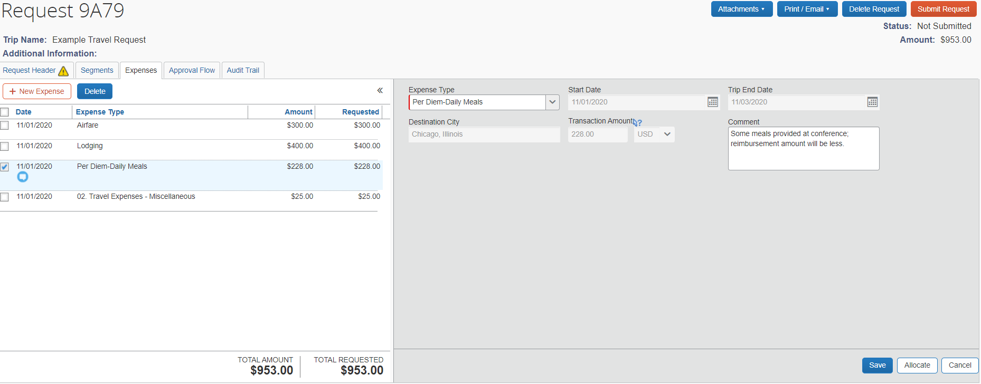
Figure 1: Example travel request with a Per Diem line and a comment noting the final amount will be less than estimated
Alternatively, if the traveler wishes to be more specific with their travel request, they can reduce the per diem by adding a second expense line and use the expense type Per Diem Reduction. The Per Diem Reduction should be a negative value.

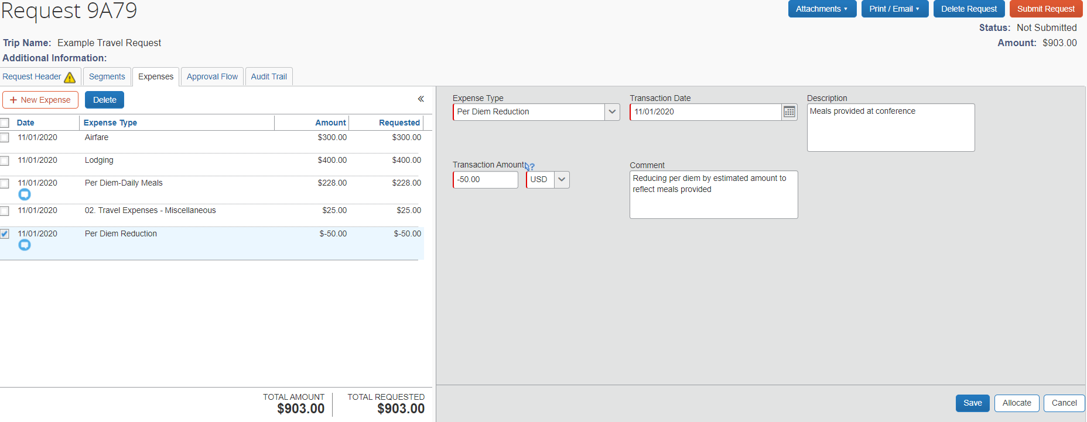
Figure 2: Example travel request with a Per Diem Reduction line and a comment noting the reduction is due to meals provided at a conference

Expense Reports
The expense report reflects the actual expenses the traveler incurred and will be the reimbursed; it likely differs from the estimated totals of the travel request and it should take into account any necessary reductions. While entering the itinerary on the expense report, the user is able to subtract meals that were provided and should not be part of the per diem reimbursement.
If the user is not permitted to request reimbursement based on the default US General Services Admin rate, they can further reduce their per diem reimbursement by adding a Per Diem Reduction line. The Per Diem Reduction should be a negative value, and it will reduce the total amount the traveler is reimbursed.

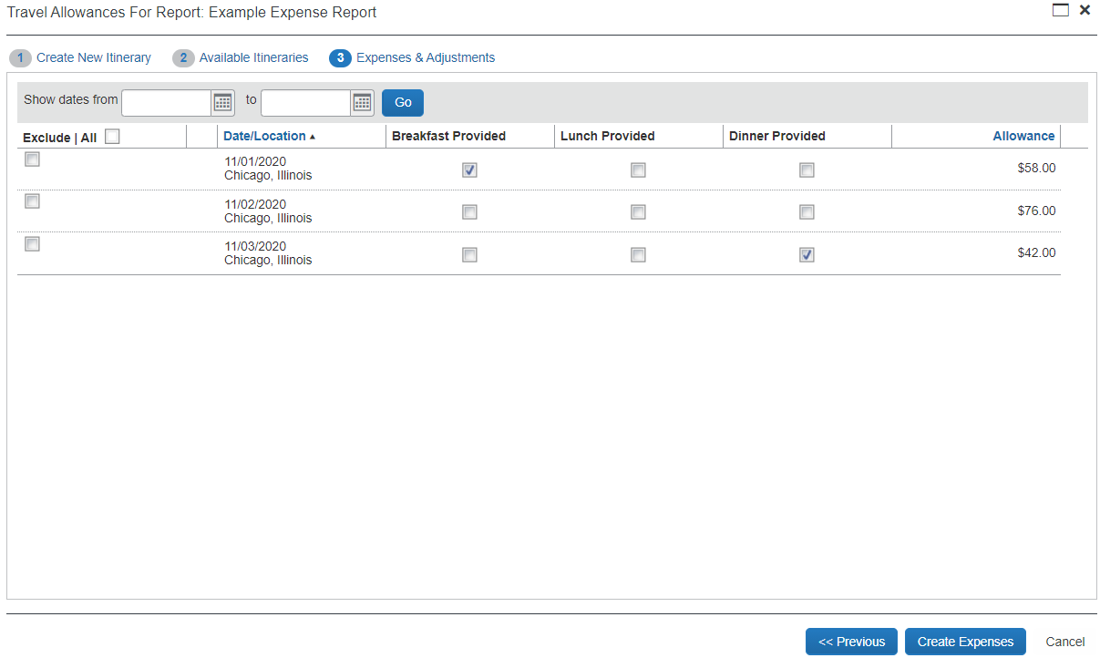
Figure 3: The Travel Allowances function that allows users to reduce their per diem reimbursement by meals provided

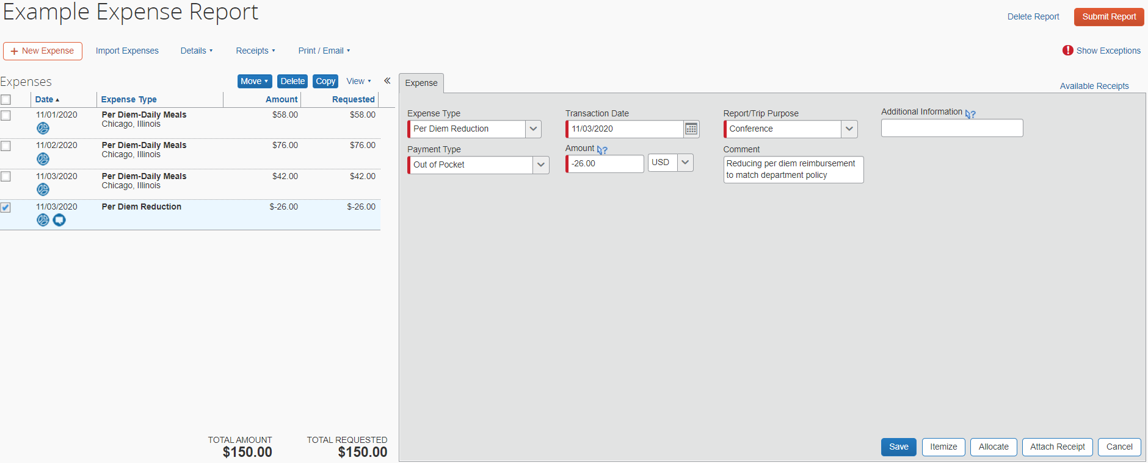
Figure 4: Example expense report with per diem lines and a Per Diem Reduction line, reducing the total reimbursement amount

