How to Schedule an Appointment in TutorTrac

1. Log-in to Tutor Trac using your UC username and password. You can access this website directly at lacscheduling.uc.edu or via the Learning Commons website, uc.edu/learningcommons
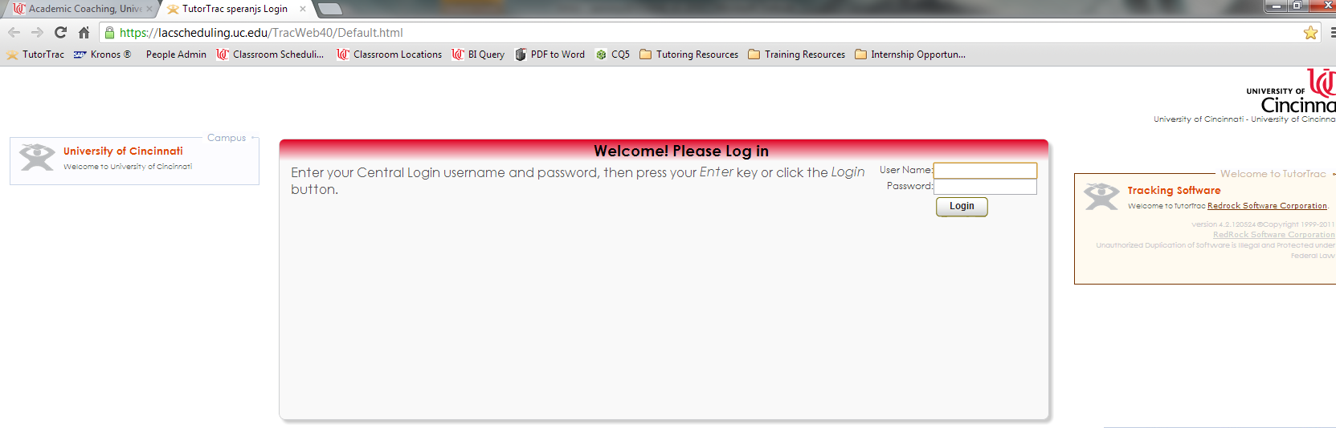
2. To schedule a new appointment, click on the “Search Availability” button on the left side of your screen
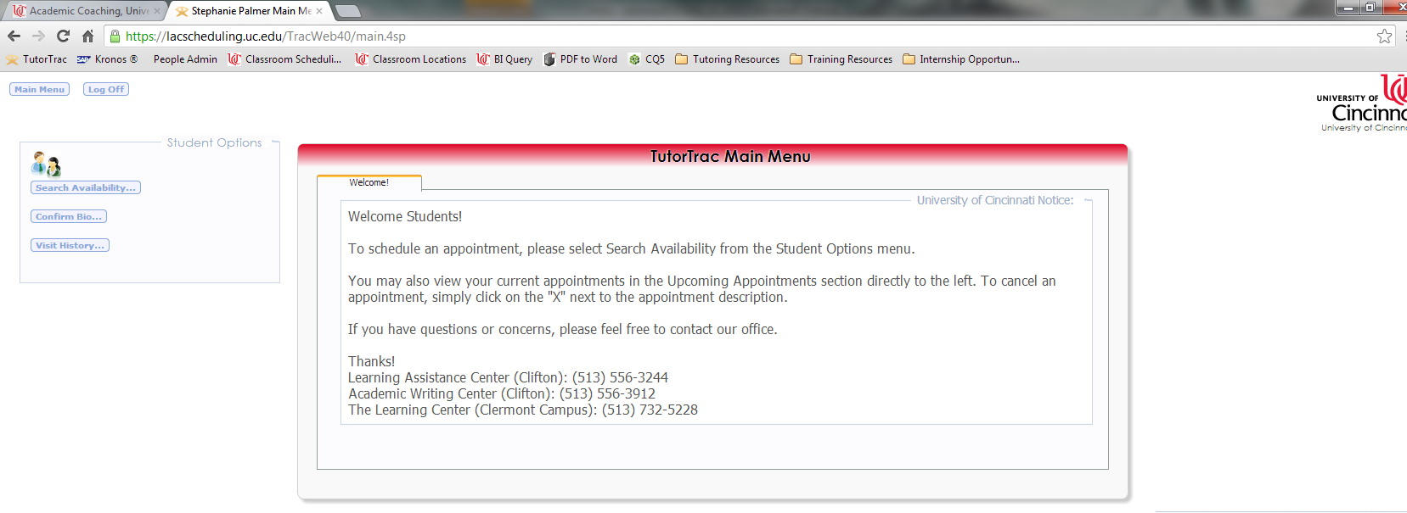

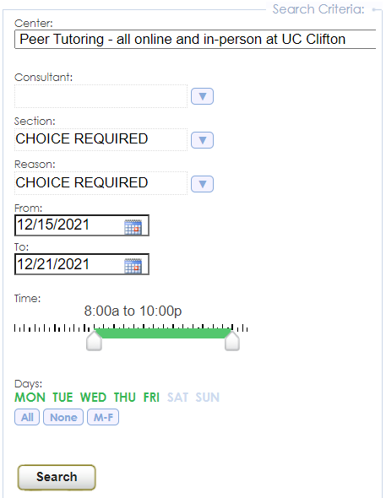
3. Next, select the appropriate service from the “Center” drop-down on the left side of your screen. For online tutoring sessions, select the “Peer Tutoring – all online and in-person at UC Clifton” center
a. Select the class you want to work on from the “Section” drop-down. This step is required.
b. Select whether you want in-person or online tutoring from the “Reason” drop-down. This step is required.

c. Use the time scroll to select your availability. Times shown in green will be included in the search. The default times will show all availability.

4. Your search will provide a list of available appointments organized by day and tutor. Once you have selected a time that you would like, click on that time slot.
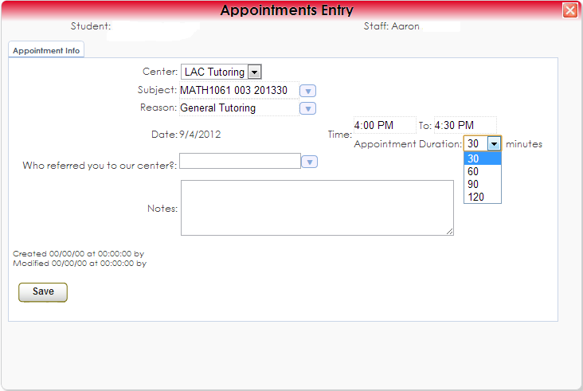
a. Double-check your “Reason” from the drop-down options. This step is required.
b. Select the appointment duration.
c. Enter any notes for your tutor about the appointment. This could include specific content you wish to cover.
d. Click “Save” to finalize your appointment. You will receive an email confirmation to your UC email address.
6. To join a virtual appointment, log in to TutorTrac up to 15 minutes before your appointment and click the link in the middle of the screen.

How to Check or Cancel Your Upcoming Appointments:

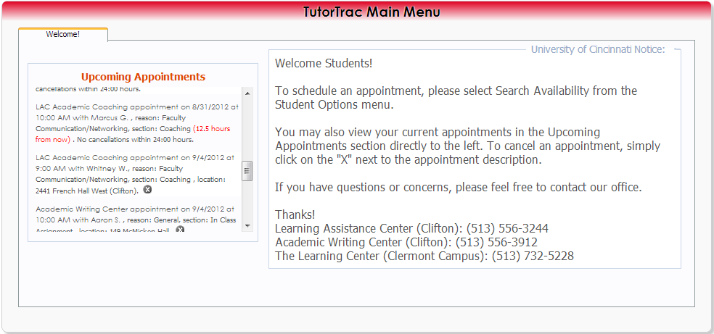
1. Log-in to Tutor Trac using your UC username and password. You can access this website directly at https://lacscheduling.uc.edu.
2. In the center of the screen, you will see a list of your upcoming appointments.
3. To cancel an appointment, click on the “X” following the appointment description.
Note: Appointments cannot be cancelled online within 24-hours of their scheduled start time. Please contact the correct Front Desk to cancel an appointment within 24-hours. You can find the Front Desk contact information and No-Show policy on the last page of this guide

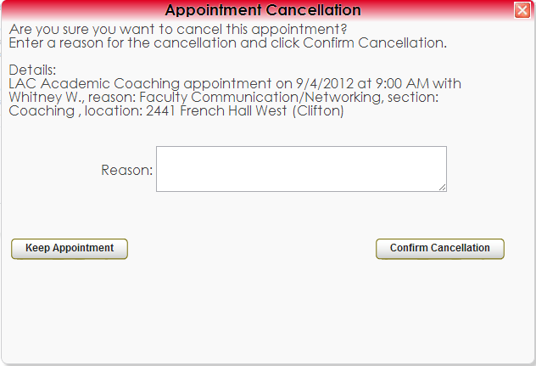
4. Enter a reason for your cancellation.

5. Select “Confirm Cancelation”

If you have any questions, concerns, or wish to cancel in less than 24-hours, please contact the appropriate Learning Commons Front Desk. You may cancel your appointment online with more than 24-hours’ notice. If you wish to cancel with less than 24-hours’ notice, you will need to call the Learning Commons Front Desk. Cancellation less than 24-hours in advance will result in a no-show.
- For Clifton appointments:
  - (513) 556-3244
  - LearningCommons@uc.edu
  - 2510B French Hall West
- For Clifton AWC:
  - (513) 556-3912
  - AcadWC@uc.edu
  - 401N Langsam Library
- For Clermont appointments:
  - (513) 558-8319
  - UCCLearningCommons@uc.edu
  - 106 Jones

Learning Commons No-Show Policy
Students must cancel all appointments at least 24-hours in advance. Students who cancel within 24-hours, arrive 10 or more minutes late, or fail to attend will receive a No-Show status for their workshop or appointment.
Two No-Show statuses will result in a block from appointment-based services and workshops until the student meets with a professional staff member. Scheduling rights will be reinstated once the student has met with a Learning Commons staff member. Any future appointments scheduled at the time of receiving a second No-Show will be canceled.
Three No-Show statuses will result in a block from appointment-based services and workshops until the end of the semester.

