Fifth Southwest Ohio Regional Transfer Summit
  - Cincinnati State Technical and Community College
The Summit Restaurant
September 27, 2019

Summit Vision
Key to Ohio’s economic future is the ability of its citizens to attain a higher education. The overarching goal of the Southwest Ohio Regional Summits are to bring about a dramatic increase in college access, success, and completion among southwest Ohio students through meaningful and sustained collaborations among the colleges and schools in the region.
The values of the Southwest Ohio Regional Transfer Compact are:
- People: Students, faculty, staff, employers, administrators
- Commitment: Belief in the overarching goals, institutional and regional
- Mindset: Critical minds, open minds, outside-the-box thinking, curiosity
- Partnerships: Regional, across sectors and institutions
- Relationships: Collegial, professional, ethical, respectful, trusting
- Strategies: Goal-oriented, fiscally responsible, progressive, efficient and effective
As partners in the Compact, member institutions host regional summits twice each year which bring together key stakeholders from higher and secondary education, government, and industry to address topics, questions and issues that relate to Compact goals.
Anticipated Compact outcomes include, but are not limited to: bilateral academic agreements, financial aid consortium agreement, dual enrollment, dual degree programs, career exploration and counseling collaborations, data sharing, analysis, and discussions, transfer toolkit, and shared solutions-oriented research and development of talent pipelines in the region through collaborations among school districts, two-year and four-year colleges and universities, and employers.
Partnering Institutions:
- Cincinnati State Technical and Community College
- Miami University (Oxford and Regional Campuses)
- Sinclair Community College
- Southern State Community College
- University of Cincinnati (Main Campus and Regional Campuses)
- University of Dayton
Steering Team Members:
- Kimberly Collins – Program Director for University Partnerships, Sinclair Community College
- Kimberly Ellison – Academic/Career Advisor, Southern State Community College, Brown Campus
- Carolyn Haynes, Associate Provost, Miami University
- Donnie McGovern, Director, Center for Pathways Advising and Student Success, University of Cincinnati
- Cathy Moore, Regional Director, Strategic Enrollment Initiatives, Miami University Regionals
- Hideo Tsuchida, Director of Institutional Partnerships and Program Development, University of Dayton
- Myshamil Walker, Transfer Center Coordinator and Math Faculty, Cincinnati State Technical & Community College

Summit Agenda

10:30 am Registration and Brunch
11:00 am Welcome and Introductions
11:15 – 12:15 pm Program Highlights (Two-Year Institutions)
      - Cincinnati State Technical & Community College
      - Sinclair Community Colleges
      - Southern State Community College
      - UC Clermont and UC Blue Ash

12:15 – 12:30 pm Break
12:30 – 1:45 pm Program Highlights (Four-Year Institutions)
      - Miami University (Oxford and Regionals)
      - Mount St. Joseph College (Exploring Transfer Options)
      - University of Cincinnati (Clifton)
      - University of Dayton
      - Wright State

1:45 pm Instructions for Afternoon
2:00 – 3:00 pm Cocktail Hour
Participants move around the room to develop tentative agreements with leaders from other institutions.
3:00 – 3:30 pm Wrap-Up
Institutions will report on the agreements and other activities they plan to pursue with other institutions.
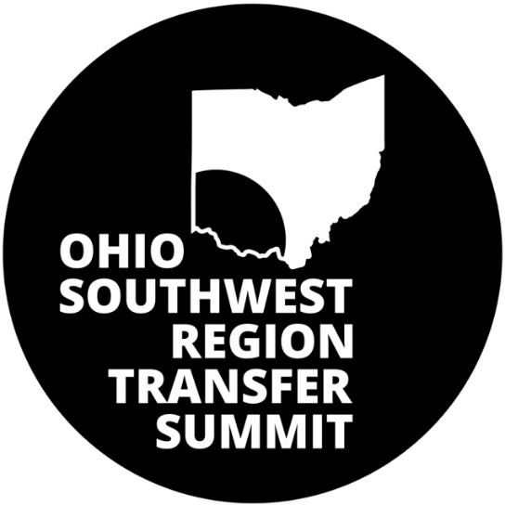

Summit Participants

Cincinnati State Technical & Community College
- Myshamil Walker, Transfer Center Coordinator and Math Faculty, myshamil.walker@cincinnatistate.edu
- Doug Bowling, Dean, Center for Innovative Technologies, douglas.bowling@cincinnatistate.edu
- Kim McMillan, Associate Dean, Center for Innovative Technologies, kim.mcmillan@cincinnatistate.edu
- Larry Feist, Program Chair, Electro-Mechanical Engineering Technology, lawrence.feist@cincinnatistate.edu

Miami University (Oxford)
- Diane Delisio, Associate Dean, College of Engineering and Computing, delisid@miamioh.edu
- Kathy Gutheil, Director of International and Transfer Admission, Kathy.gutheil@miamioh.edu
- Sarah Unger, Senior Assistant Director, Transfer Initiatives, sarah.unger@miamioh.edu

Miami University Regionals
- Ann Shelton, Regional Director, Strategic Enrollment Initiatives, neelyam@miamioh.edu
- Mert Bal, Professor, Department of Engineering Technology, balm@miamoh.edu

Mount St. Joseph University
- Amy Wolf, Assistant Director for Adult and Transfer Recruitment, amy.wolf@msj.edu
- Christa Currie, Associate Provost for Academic Affairs, christa.currie@msj.edu

Sinclair Community College
- Kimberly Collins – Program Director for University Partnerships, kimberly.collins7973@sinclair.edu
- Eric Dunn, Asst. Dean of SME Division, eric.dunn@sinclair.edu
- Trish Burke-Williams, Advising Manger for STEM, patricia.william4128@sinclair.edu

Southern State Community College
- Stephanie Meade, smeade1@sscc.edu

University of Cincinnati (Clifton)
- Donnie McGovern, Director, Center for Pathways Advising and Student Success, donnie.mcgovern@uc.edu
- Gretchen Hart – Director, Undergraduate Advising, College of Engineering and Applied Science, gretchen.hart@uc.edu
- Rachel Fulton – Senior Academic Evaluator, Rachel.fulton@uc.edu

UC Blue Ash
- Renee Rivers, Academic Advisor, renee.rivers@uc.edu

UC Clermont

University of Dayton
- Hideo Tsuchida, Director of Institutional Partnerships and Program Development, Office of Registrar, htsuchida1@udayton.edu
- Scott Segalewitz, Associate Dean for Experiential Learning and Student Success, School of Engineering, segalewitz@udayton.edu

Wright State University
- Don Miller, Director of Transfer, Transition, and Orientation, don.miller@wright.edu
- Angela Griffith, Assistant Dean for Academic Affairs, College of Engineering, angela.griffith@wright.edu

Participating Institutions and Programs

Cincinnati State Technical and Community College
- A.A.S., Electrical Engineering Technology – Biomedical Equipment Major
- A.A.S., Electrical Engineering Technology – Electronic Systems Major
- A.A.S., Electrical Engineering Technology – Power Systems Major
- A.A.S., Electro-Mechanical Engineering Technology – Energy Major
- A.A.S., Electro-Mechanical Engineering Technology – Laser Major
- A.A.S., Mechanical Engineering Technology – Design Major
- A.A.S., Mechanical Engineering Technology – Manufacturing Major
- A.A.S., Pre-Engineering

Miami University (Oxford)
- B.S., Bioengineering
- B.S., Chemical Engineering
- B.S., Computer Engineering
- B.S., Electrical Engineering
- B.S., Engineering Management
- B.S., Manufacturing Engineering
- B.S., Mechanical Engineering

Miami University Regionals
- B.S., Engineering Technology- Bachelor of Science in Applied Science

Mount St. Joseph University

Sinclair Community College
- A.A.S., Engineering and Engineering Technology University Transfer

Southern State Community College

University of Cincinnati (Clifton)
- B.S., Aerospace
- B.S., Architectural Engineering
- B.S., Biomedical Engineering
- B.S., Civil Engineering
- B.S., Computer Engineering
- B.S., Electrical Engineering
- B.S., Environmental Engineering
- B.S., Mechanical Engineering

University of Cincinnati (Blue Ash)
- A.A.S., Pre-Engineering Pathway

University of Dayton
- B.S., Electrical/Computer Engineering
- B.S., Civil and Environmental Engineering
- B.S., Chemical and Materials Engineering
- B.S., Engineering Technology (included: Mechanical, Electronic and Computer, Industrial and Manufacturing)
- B.S., Discover Engineering and Discover Engineering Technology

Wright State University (College of Engineering and Computer Science)
- B.S., Computer Engineering
- B.S., Electrical Engineering
- B.S., Mechanical Engineering
- B.S., Materials Science and Engineering
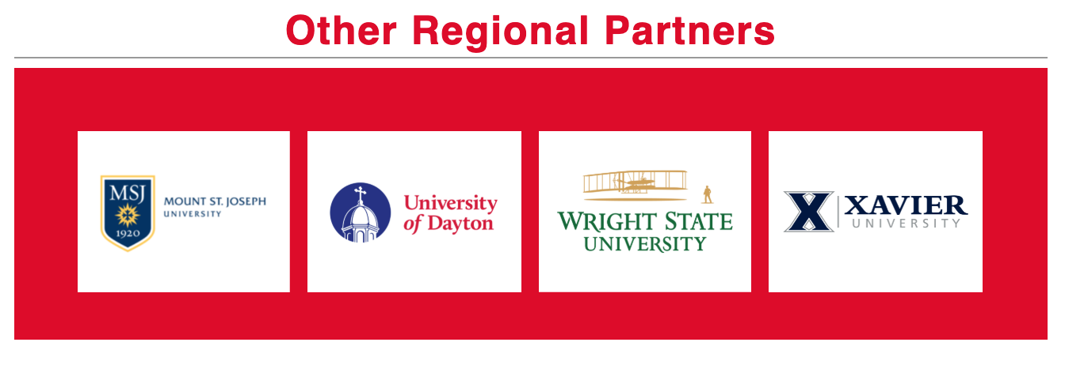
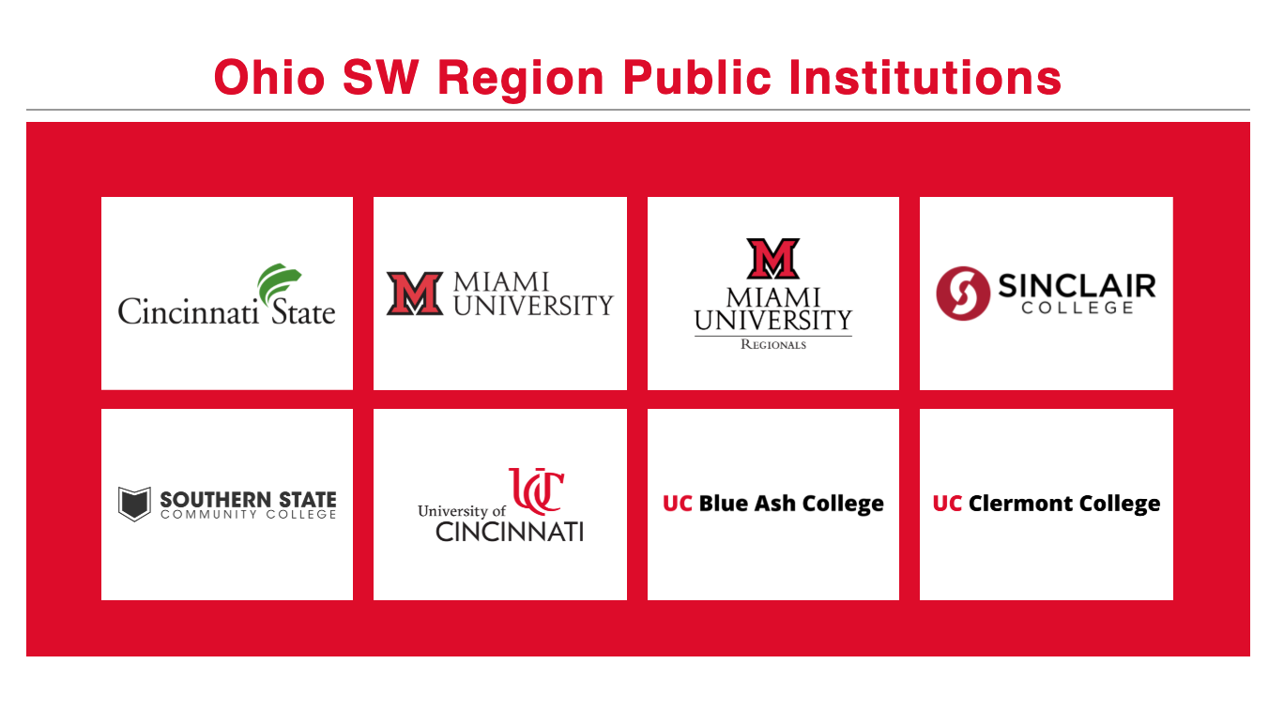

Program Descriptions

Cincinnati State Technical & Community College

Electrical Engineering Technology
Contact Information: Ralph Whaley, Program Chair EET
Contact email address: ralph.whaley@cincinnatistate.edu
Number of Enrolled Students in Program: 150
Number of Faculty in Program: 3
Internship Requirement: Yes
Additional Information: Nothing numerical, but all of the degree programs within the EET program are experiencing growth at the moment, especially the BMT and PSET programs. The students are fortunate to be graduating in a market where their skills are in high-demand, and as a program chair, I am constantly receiving requests from employers for our students. There is literally a waiting list for our students in these programs. Additionally, I receive email from many students that have gone on to four-year degree and have felt tremendously well prepared for that transition.

Pre-Engineering
Contact Information: George Armstrong, Program Chair
Contact email address: george.armstrong@cincinnatistate.edu
Number of Enrolled Students in Program: 80
Number of Faculty in Program: 1
Internship Requirement: No
List other special opportunities you offer students in the program:
- Ohio Transfer Module Degree
- Pathways Scholarship
Significant Program Outcomes: Transfers of Graduates (past 5 years)
- University of Cincinnati(College of Engineering) = 9
- Miami University (Oxford and Regionals) = 3
- Wright State = 1
- Ohio University = 1
- Ohio State = 3
- North Dakota = 1
- Purdue = 1
- UNLV = 1
- Alabama = 2

Miami University (Oxford)

Bachelor of Science, Bioengineering
Contact Information: Brian Kirkmeyer, KBW Senior Assistant Dean for Student Success
Contact email address: kirkmebp@miamioh.edu
Number of Enrolled Students in Program: 166 (from 10/15/18; this semester's enrollment available 10/15/19)
Number of Faculty: 1
Internship Requirement: No
Other Special Opportunities: Students can apply to participate in the Lockheed Martin Leadership Institute.
Undergraduate students can work on research with a faculty member.
Active chapter and good student participation in Engineers without Borders.
Year-long capstone project, many with real clients.

Program Outcomes: For May 2019 grads (96% response rate),
82.1% had a job or were continuing their education at the time of graduation.
53.6% had one or more internships.
For all 2017-2018 grads in the College of Engineering and Computing, 97.1% had a job or were continuing their education within 6 months of graduation.
Six year graduation rate for College of Engineering and Computing grads is 75.5% compared to ASEE national rate (from 2015) of 59%

Bachelor of Science, Chemical Engineering
Contact Information: Brian Kirkmeyer, KBW Senior Assistant Dean for Student Success
Contact email address: kirkmebp@miamioh.edu
Number of Enrolled Students in Program: 180
Number of Faculty in Program: 15
Internship Requirement: No
Other Special Opportunities: Students can apply to participate in the Lockheed Martin Leadership Institute. Undergraduate students can work on research with a faculty member. Active chapter and good student participation in Engineers without Borders.
Program Outcomes: For May 2019 Chemical Engineering grads (80.5% response rate),
72.7% had a job or were continuing their education at the time of graduation.
72.7% had one or more internships.
For all 2017-2018 grads in the College of Engineering and Computing, 97.1% had a job or were continuing their education within 6 months of graduation. For Chemical Engineering grads, 95.8% had a job or were continuing their education within 6 months of graduation.
Six year graduation rate for College of Engineering and Computing grads is 75.5% compared to ASEE national rate (from 2015) of 59%

Bachelor of Science, Computer Engineering
Contact Information: Brian Kirkmeyer, KBW Senior Assistant Dean for Student Success
Contact email address: kirkmebp@miamioh.edu
Number of Enrolled Students in Program: 109
Number of Faculty in Program: 11
Internship Requirement: No
Other Special Opportunities: Students can apply to participate in the Lockheed Martin Leadership Institute. Undergraduate students can work on research with a faculty member. Active chapter and good student participation in Engineers without Borders.
Program Outcomes: For May 2019 Computer Engineering grads (85% response rate), 59% had a job or were continuing their education at the time of graduation.
70.6% had one or more internships.
For all 2017-2018 grads in the College of Engineering and Computing, 97.1% had a job or were continuing their education within 6 months of graduation. For Computer Engineering grads in that year, 100% had a job or were continuing their education within 6 months of graduation.
Six year graduation rate for College of Engineering and Computing grads is 75.5% compared to ASEE national rate (from 2015) of 59%

Bachelor of Science, Electrical Engineering
Contact Information: Brian Kirkmeyer, KBW Senior Assistant Dean for Student Success
Contact email address: kirkmebp@miamioh.edu
Number of Enrolled Students in Program: 111
Number of Faculty in Program: 11
Internship Requirement:
Other Special Opportunities: Students can apply to participate in the Lockheed Martin Leadership Institute. Undergraduate students can work on research with a faculty member. Active chapter and good student participation in Engineers without Borders.
Program Outcomes: For May 2019 Electrical Engineering grads (83% response rate), 90% had a job or were continuing their education at the time of graduation.
40% had one or more internships.
For all 2017-2018 grads in the College of Engineering and Computing, 97.1% had a job or were continuing their education within 6 months of graduation. For Electrical Engineering grads this year, 95.2% had a job or were continuing their education within 6 months of graduation
Six year graduation rate for College of Engineering and Computing grads is 75.5% compared to ASEE national rate (from 2015) of 59%

Bachelor of Science, Engineering Management
Contact Information: Bri Kir, KBW Senior Assistant Dean for Student Success
Contact email address: kirkmebp@miamoh.edu
Number of Enrolled Students in Program: 120
Number of Faculty in Program: N/A
Internship Requirement: No
Other Special Opportunities: Students can apply to participate in the Lockheed Martin Leadership Institute. Undergraduate students can work on research with a faculty member. Active chapter and good student participation in Engineers without Borders.
Program Outcomes: For May 2019 Engineering Management grads (68% response rate), 73.3% had a job or were continuing their education at the time of graduation.
80% had one or more internships.
For all 2017-2018 grads in the College of Engineering and Computing, 97.1% had a job or were continuing their education within 6 months of graduation. For Engineering Management grads in this year, 92.3% had a job or were continuing their education within 6 months of graduation.
Six year graduation rate for College of Engineering and Computing grads is 75.5% compared to ASEE national rate (from 2015) of 59%

Bachelor of Science, Manufacturing Engineering
Contact Information: Brian Kirkmeyer, KBW Senior Assistant Dean for Student Success
Contact email address: kirkmebp@miamioh.edu
Number of Enrolled Students in Program: 20
Number of Faculty in Program: 24
Internship Requirement:
Other Special Opportunities: Students can apply to participate in the Lockheed Martin Leadership Institute. Undergraduate students can work on research with a faculty member. Active chapter and good student participation in Engineers without Borders.
Program Outcomes: For May 2019 Manufacturing Engineering grads (57.1% response rate; 7 total grads, 4 responses), 50% had a job or were continuing their education at the time of graduation. 50% had one or more internships.
For all 2017-2018 grads in the College of Engineering and Computing, 97.1% had a job or were continuing their education within 6 months of graduation. For Manufacturing Engineering grads in this year, 100% had a job or were continuing their education within 6 months of graduation.
Six year graduation rate for College of Engineering and Computing grads is 75.5% compared to ASEE national rate (from 2015) of 59%

Bachelor of Science, Mechanical Engineering
Contact Information: Brian Kirkmeyer, KBW Senior Assistant Dean for Student Success
Contact email address: kirkmebp@miamioh.edu
Number of Enrolled Students in Program: 111
Number of Faculty in Program: 11
Internship Requirement:
Other Special Opportunities: Students can apply to participate in the Lockheed Martin Leadership Institute. Undergraduate students can work on research with a faculty member. Active chapter and good student participation in Engineers without Borders.
Program Outcomes: For May 2019 Mechanical Engineering grads (67.1% response rate), 66% had a job or were continuing their education at the time of graduation.
71.7% had one or more internships.
For all 2017-2018 grads in the College of Engineering and Computing, 97.1% had a job or were continuing their education within 6 months of graduation. For Mechanical Engineering grads in this year, 98.8% had a job or were continuing their education within 6 months of graduation.
Six year graduation rate for College of Engineering and Computing grads is 75.5% compared to ASEE national rate (from 2015) of 59%

Miami University Regionals

B.S., Engineering Technology
Contact Information: Mert Bal, Associate Professor
Contact email address: balm@miamioh.edu
Number of Enrolled Students in Program: 320
Number of Faculty in Program: 9
Internship Requirement: No
Other Special Opportunities: List other special opportunities you offer students in the program:
Department currently offers three ABET-accredited BS Degree Programs with concentrations in:
1) Electromechanical Engineering Technology (EMET)
2) Mechanical Engineering Technology (MET)
3) Electrical and Computer Engineering Technology (ECET)
The fourth concentration is the Robotics Engineering Technology (RET). RET is a new program and is currently under development. RET program will start accepting students in 2020.
All the EMET and ECET program courses are offered to distance learning via synchronous distance delivery methods (via IVDL and Webex). Students who transfer to Miami from MIami's partner colleges can continue taking Miami classes from their host colleges via video/web conferencing.
Our BS degree programs have been designed as degree completion programs and they accept transfer students with an associate's degree in an engineering or engineering technology discipline. Most technical associate degree coursework credits are transferred from Miami's partner colleges via articulation agreements.
Department also offers Face-to-face classes. The face-to-face classes are offered in Miami Hamilton and MIddletown campuses.
All program courses are offered in the evenings and each class typically occurs one evening a week. All ENT courses have built-in lab/project components to emphasize hands-on education.
Program Outcomes: Our programs have 100% placement rate. This trend is constant for over the past three years.
Department also has significantly high completion rate. The class schedules are flexible and the frequency of course offerings make it a suitable choice for both full-time and part-time students.
Department regularly offers merit and need-based scholarships. Please see the list of the scholarships/awards here: https://miamioh.edu/regionals/academics/departments/ent/academics/scholarships-awards/index.html
The department has a growing number of research-active faculty who actively work on sponsored research and industrial projects on Robotics, Industrial Automation, Advanced Manufacturing, Additive Manufacturing, Industry 4.0, Wireless Sensor Networks, Fluid-Structure Interactions, Mechanisms Design, Smart Mechatronics Systems, Distributed Intelligent automation and control. Interested students may apply to be involved in these research projects as student assistants. The department also offers scholarships to fund capstone projects (senior design projects).

Sinclair Community College

Engineering & Engineering Technology University Transfer
Contact Information: Eric Dunn, Assistant Dean
Contact email address: eric.dunn@sinclair.edu
Number of Enrolled Students in Program: 600
Number of Faculty in Program: 35
Internship Requirement: No
Other Special Opportunities: UD/Sinclair Academy and The Wright Path
Program Outcomes: Transfer universities include:
- Central State University
- Miami University
- Ohio State University
- University of Cincinnati
- University of Dayton
- University of Kentucky
- Wilberforce University
- Wright State University

University of Cincinnati, Blue Ash

A.A.S., Pre-Engineering
Contact Information: Renee Rivets, Senior Academic Advisor
Contact email address: renee.rivets@uc.edu
Number of Enrolled Students in Program: 100
Number of Faculty in Program: N/A
Internship Requirement: No
Other Special Opportunities: Pre-Engineering at UCBA is designed to be a one-year pathway for eligible students who are seeking transition to the College of Engineering & Applied Science on the Uptown campus. The pathway consists of the required science and math courses for admission consideration. Students also enroll in English, first year ENED courses, and general education courses. Successful students will transition to CEAS at the end of their first year.

University of Cincinnati (Clifton)

College of Engineering and Applied Science
Contact Information: Gretchen Hart, Director of Undergraduate Advising
Contact email address: gretchen.hart@uc.edu
Number of Enrolled Students in Program: 5000
Number of Faculty in Program: 158
Internship Requirement: Yes
Other Special Opportunities: Mandatory 5 co-ops., Study Abroad Opps, Prof Dev Courses, Student Wellness, and Academic supports
Program Outcomes: Retention up to 90%, Grad rate up to 75.1%, Up to 14 full time advisors, New Director of Women in Engineering

University of Dayton

B.S., Electrical/Computer Engineering
Contact Information: Michelle Strunks, Assistant Dean
Contact Email: mstrunks1@udayton.edu
Number of Enrolled Students in Program: 338
Number of Faculty in Program: 15
Internship Requirement: No
Other Special Opportunities: Co-operative Education, Education Abroad, Engineering Clubs and Organizations, ETHOS (Engineers in Technical Humanitarian Opportunities of Service Learning), Undergraduate Research Makerspace

B.S., Civil and Environmental Engineering
Contact Information: Michelle Strunks, Assistant Dean
Contact Email: mstrunks1@udayton.edu
Number of Enrolled Students in Program: 206
Number of Faculty in Program: 12
Internship Requirement: No
Other Special Opportunities: Co-operative Education, Education Abroad, Engineering Clubs and Organizations, ETHOS (Engineers in Technical Humanitarian Opportunities of Service Learning), Undergraduate Research Makerspace

B.S., Chemical and Materials Engineering
Contact Information: Michelle Strunks, Assistant Dean
Contact Email: mstrunks1@udayton.edu
Number of Enrolled Students in Program: 257
Number of Faculty in Program: 11
Internship Requirement: No
Other Special Opportunities: Co-operative Education, Education Abroad, Engineering Clubs and Organizations, ETHOS (Engineers in Technical Humanitarian Opportunities of Service Learning), Undergraduate Research Makerspace

B.S., Engineering Technology (Mechanical, Electronic and Computer, Industrial and Manufacturing)
Contact Information: Michelle Strunks, Assistant Dean
Contact Email: mstrunks1@udayton.edu
Number of Enrolled Students in Program: 271
Number of Faculty in Program: 12
Internship Requirement: No
Other Special Opportunities: Co-operative Education, Education Abroad, Engineering Clubs and Organizations, ETHOS (Engineers in Technical Humanitarian Opportunities of Service Learning), Undergraduate Research Makerspace

B.S., Discover Engineering and Discover Engineering Technology
Contact Information: Michelle Strunks, Assistant Dean
Contact Email: mstrunks1@udayton.edu
Number of Enrolled Students in Program: 140
Number of Faculty in Program: N/A
Internship Requirement: No
Other Special Opportunities: Co-operative Education, Education Abroad, Engineering Clubs and Organizations, ETHOS (Engineers in Technical Humanitarian Opportunities of Service Learning), Undergraduate Research Makerspace

B.S., Mechanical Engineering
Contact Information: Michelle Strunks, Assistant Dean
Contact Email: mstrunks1@udayton.edu
Number of Enrolled Students in Program: 856
Number of Faculty in Program: 20
Internship Requirement: No
Other Special Opportunities: Co-operative Education, Education Abroad, Engineering Clubs and Organizations, ETHOS (Engineers in Technical Humanitarian Opportunities of Service Learning), Undergraduate Research Makerspace

Wright State University

B.S., Computer Engineering
Contact Information: Karen Meyer, Director of Undergraduate Programs, Computer Science and Engineering
Contact Email Address: cse-dept@wright.edu
Number of Enrolled Students in Program: 167
Number of Faculty in Program: 22
Internship Requirement: No
Other Special Opportunities: Students in this program have the opportunity to craft a program that combines course in hardware design, systems programming, embedded systems, microprocessors, FPGA, VLSI, and robotics and other core areas of computer engineering. There are many on-campus opportunities for employment that allows students to assist in laboratories. In addition, there are opportunities for both unfunded and fund research with the program faculty, and readily available company internship opportunities during the academic year and the summer.
Many students choose to enroll in the 4+1 BS-MS program that allows a student to complete a both a bachelors and master’s degree in five year at a reduced cost.
Program Outcomes: There are a number of active student organizations including the Association of Computing Machinery (ACM), Cyber Security Club, Women in Computer Club, Society of Women Engineers, etc. There are several special laboratories accessible to students including the Boffin Factory which is a design/build laboratory that is open to all students who want to work on class projects and/or put together a team to build something interesting. The rate of employment within six months of graduation exceeds 90%. Most students receive multiple jobs offers and have jobs lined-up prior to graduation.

B.S., Computer Science
Contact Information: Karen Meyer, Director of Undergraduate Programs, Computer Science and Engineering
Contact Email Address: cse-dept@wright.edu
Number of Enrolled Students in Program: 330
Number of Faculty in Program: 22
Internship Requirement: No
Other Special Opportunities: Students in this program have the opportunity to craft a program that combines course in hardware design, systems programming, embedded systems, microprocessors, FPGA, VLSI, and robotics and other core areas of computer engineering. There are many on-campus opportunities for employment that allows students to assist in laboratories. In addition, there are opportunities for both unfunded and fund research with the program faculty, and readily available company internship opportunities during the academic year and the summer.
Many students choose to enroll in the 4+1 BS-MS program that allows a student to complete a both a bachelors and master’s degree in five year at a reduced cost.
Program Outcomes: There are a number of active student organizations including the Association of Computing Machinery (ACM), Cyber Security Club, Women in Computer Club, Society of Women Engineers, etc. There are several special laboratories accessible to students including the Boffin Factory which is a design/build laboratory that is open to all students who want to work on class projects and/or put together a team to build something interesting. The rate of employment within six months of graduation exceeds 90%. Most students receive multiple jobs offers and have jobs lined-up prior to graduation.

B.S., Electrical Engineering
Contact Information: Fred Garber, Chair, Computer Science and Engineering
Contact Email Address: fred.garber@wright.edu
Number of Enrolled Students in Program: 217
Number of Faculty in Program: 14
Internship Requirement: Yes

B.S., Mechanical Engineering
Contact Information: Heather Casto, Academic Programming Director, Computer Science and Engineering
Contact Email Address: heather.casto@wright.edu
Number of Enrolled Students in Program: 700
Number of Faculty in Program: 22
Internship Requirement: No
Other Special Opportunities: It’s possible to become certified in Solidworks at the end of our first year Solid Modeling course. The full degree program is also available at our Lake Campus in Celina, OH.
Program Outcomes: Internships are not a requirement, but the majority of our students hold internships during the completion of their degree program with no additional time until graduation. This program is ABET accredited.

B.S., Material Science and Engineering
Contact Information: Heather Casto, Academic Programming Director, Computer Science and Engineering
Contact Email Address: heather.casto@wright.edu
Number of Enrolled Students in Program: 50
Number of Faculty in Program: 22
Internship Requirement: No
Other Special Opportunities: It’s possible to become certified in Solidworks at the end of our first year Solid Modeling course. The full degree program is also available at our Lake Campus in Celina, OH.
Program Outcomes: Internships are not a requirement, but the majority of our students hold internships during the completion of their degree program with no additional time until graduation. This program is ABET accredited.

Articulation Agreement Worksheet

Originating Institution:

Degree/Program:

Target Institution and Campus:

Degree/Program:

Suggested Schedule at [Originating Institution}
Term | Course Name | Credits
Year 1, Fall Semester

Year 1, Spring Semester

Year 2, Fall Semester

Year 2, Spring Semester

Suggested Schedule at [Target Institution]
Term | Course Name | Credits
Year 1, Fall Semester

Year 1, Spring Semester

Year 2, Fall Semester

Year 2, Spring Semester

Advising Contacts
Originating Institution: [List name and contact info]

Target Institution: [List name and contact info

