At UDayton – 9:30am-2:30pm

Welcome/Intros
  - Welcome from Jason Reinoehl (VP Strategic EM)
    - Why invest in Transfer
      - Linking Learning/Scholarship to Leadership/Service (Mission Sense)
      - Good Business Sense – affordability for students to diversify populations
      - Adaptation/Change - Institutional Quality Building
    - "Learn our way forward"
    - Program Highlights:
      - 1+2+1 – NURS partnership with Sinclair
      - UD Sinclair Academy
    - Asked students what they're expecting from transfer credit
      - AP/IB courses taken seriously
      - CCP courses taken seriously
  - Miami OH – Sarah, Lauren, Ann, Kathleen, Carolyn
  - Southern State – Joyce, Stephanie
  - UC – Donnie, Kaci, Rachel
  - Cincinnati State – My
  - Wilmington – Sharon
  - Mt. St. Jo – Amy
  - Sinclair – Kim, Katelyn
  - UD – Julia, Denise?, Hideo
  - Xavier – Erica

Summit Objectives & Transfer Playbook Review – See Agenda below
<<Southwest Ohio Regional Transfer Summit Agenda 3-6-2020.pdf>>

Presentations of Promising Practices
  - Sinclair & Partners – Kim Collins (Sinclair)
    - Top Transfer Universities: Miami, Ohio State, Ohio U, UC, Dayton, Wright State
    - Partner Services: Articulated Academic Pathways, Transfer Scholarships, Weekly Visits from Transfer Representatives, Waived transfer app fee, 3+1 Options
    - Do we use their transfer visit space at all
    - Proximity dictates preference re: programs
    - Interest in increased partnership with UC
    - Wright State Partnership: Wright Path Program
      - 2+2 style program (Associate completion)
      - Wright.edu/wrightpath - application for joint admission (leading to guaranteed admission dependent on major and gpa)
      - 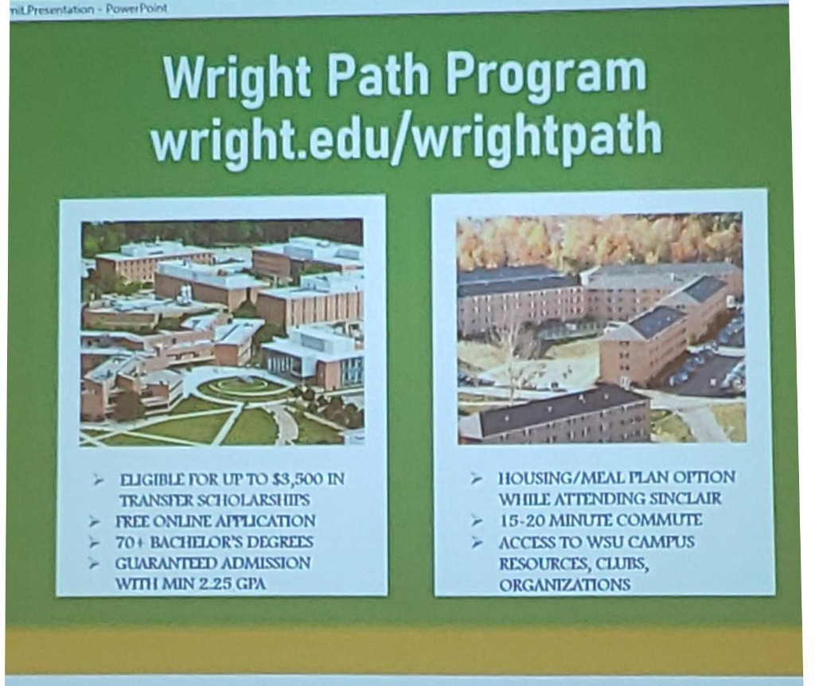
    - UD Sinclair Academy – see notes from ODHE Transfer Workshop
      - Strengths: Continued Growth, Affordability/Access, Strong Academic Pathways, Advising, Strong Partnership, Student Success in/out classroom
      - Challenges: Student Engagement, Advising, Onboarding for Spring, Test Credential Policies, CCP Early Advising, Early Outreach at Sinclair
      - Opportunities: Centralized Academy Advising (Academic, Engagement, Transition) & Student Engagement (Student Org, Mentoring Program)
  - Cincinnati State & Partners
    - Wilmington College (resident partner)
    - Mount St. Joseph (visiting partner – 1x/week)
    - Miami Regionals (resident partner)
    - CState2NKU – joint admission (both current and alumni CS students)
    - 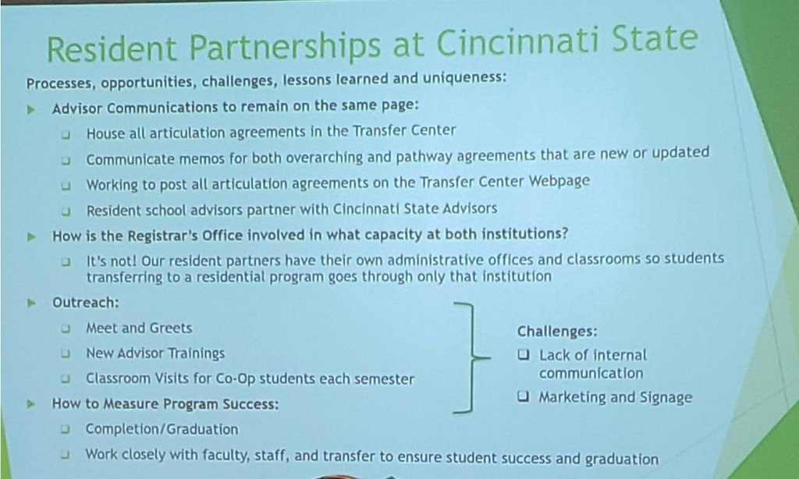
    - CCP to Degree (3 pathways) with WGU Ohio
    - Resident Partners:
      - Outreach: Meet/Greets, New Advisor Trainings, Classroom Visits for Co-op
      - Challenges: Lack of Internal Communication, Marketing/Signage
    - Wilmington College Partnership:
      - Stemmed out of on-site evening course options (started in 2003)
      - Programs: Acct, BusAdmin, Org Leadership, Education Studies, Multimedia, Liberal Studies
      - Must earn associates from CS to receive discounted tuition rate; 2.5 GPA (probation option if lower)
      - Waived fees including app fee
      - Benefits: Dual Advising, CS Student Services, GE Certified, Tuition Discount, Double Majors, Credit Transferability, Free Parking
        - GE Certified – AA, AS, OTM certified completion
    - Mount St. Joseph
      - Three Education Tracks w/licensure (dual enrollment)
        - Primary Ed (Pre-K-5th grade)
        - Special Ed (up to grade 12)
        - Dual Primary/Special Ed
      - Earn ECE degree from CS, 2.8 GPA for School of Ed
    - Miami Regionals
      - Paths into EET, CET, MET
      - Virtual – not Online (via WebEx)
  - Southern State & Partners
    - Most Popular 4Yrs: Franklin (Online), Miami, Lindsey Wilson, Shawnee State
    - Franklin:
      - 3+1, advisor on campus, online only programs
    - Miami:
      - 2+2, "Stay here, go far"
      - 3-tier Agreement: Associates degree, Bridge courses, Miami Courses via WebEx, 1 off-site visit for capstone
  - Opportunity space for UCO programs

Reflection/Lunch
  - Next Summit: Fall (Friday) -
    - Sinclair Courseview Campus
    - Possible Topic: Transfer Visits & Advising
    - Spring – Miami Oxford; topic = business pathways?

Presentations of Promising Practices
  - Miami Regional & Partners
    - Columbus State Partnership:
      - Miami is a Preferred Pathways Partner
        - Priority/Early registration for table visits
        - Transfer Center advising appointments
        - Special events for P3
        - Student Success Workshop each term
        - Institutional Blackboard site
        - Co-located Distance Learning
  - UC & Partners

Conversations in the Room:
  - Reflection from Perspective of Current Role
  - Share your Reflections
  - What Keeps You Up at Night – Partnership Challenges
  - Wrap Up

