How to Write a Resume

An effective resume is more than a list of your skills and experience. It serves as your professional introduction. It is often the only source of information a potential employer will have when deciding whether or not to invite you in for an interview. Moreover, most employers receive hundreds of resumes for any given opportunity and have very little time to evaluate each one.

Your resume must therefore clearly convey your skills, strengths and relevant experience, and do so in an efficient and visually appealing manner.

The following guide will walk you through creation of a resume that will best represent you to the organizations, programs and opportunities you hope to pursue.

What is a Curriculum Vitae?
Some employers will use resume and Curriculum Vitae (or CV) interchangeably. The principle difference is that a CV is typically longer, 2 or more pages, and will include more comprehensive information about a candidate’s research background, presentations, publications, committee memberships and other experience of an academic nature. CV’s are typically used to apply for graduate programs, charter school roles and academia.

Step 1: Choose a Template
Select a simple and appealing format for your resume. If you are just beginning your career or working for a traditional industry, you want to choose something simple. Avoid borders, colors, images or graphics. Your font size should be between 10-12 points. Your margins should be between .5” and 1.0.” You may adjust both to fit your resume onto 1 page.

*Note that some organizations allow a resume of more than 1 page. Typically graduate programs, startups, non-profits and teaching/education roles will accept a resume of more than 1 page, but it must still be concise.

Here is a sample resume template, followed by two examples of finished resumes:

YOUR NAME
Street Address, City, State Zip Code | phone number | email address
EDUCATION:
Degree, Major (Note: Required) Expected Graduation: Month Year
University of Cincinnati, Cincinnati, OH
- Minor: (If Applicable)
- Concentration: (If Applicable)
- GPA: (Generally listed if above a 3.0. List to the hundredths place, do not round up.)
- Relevant Coursework: (Note: Optional)
- Study Abroad: (Note: Optional. If used, include subject of coursework, location, as well as months and years of participation)
- Awards and Honors: (Note: Optional)

EXPERIENCE: (Note: Required)
Position Title Month Year – Month Year
Organization Name, City, State
- List your positions in reverse chronological order, beginning with your most recent position (full-time work, part-time work, internship/co-op, teaching assistantships, etc.).
- Begin each line with an action verb and include details that will help the reader understand your experience, skills, outcomes and achievements.
- Do not use personal pronouns; each line should be a phrase rather than full sentence.
- If something on your resume is in the past, use the past tense (managed, delivered, organized) and if you are still actively in the role, use the present tense (manage, deliver, organize).
- Quantify, using numbers and percentages, where possible.
- You may also include other sections, such as Research Experience, Volunteer Experience, etc.
Position Title Month Year – Month Year
Organization Name, City, State
- Begin each line with an action verb and include details that will help the reader understand your experience, skills, outcomes and achievements.
- Do not use personal pronouns; each line should be a phrase rather than a full sentence.
LEADERSHIP, ACTIVITIES, AND SERVICE: (Note: Optional)
Role Month Year – Month Year
Organization, City, State
- This section can be formatted similarly to the Experience section, or you can omit descriptions for activities.
- If this section is more relevant to the opportunity you are applying for, consider moving this above your Experience section.

SKILLS: (Note: Required)
Computer: List computer software and programming languages
Language: List foreign languages and level of fluency (If Applicable)

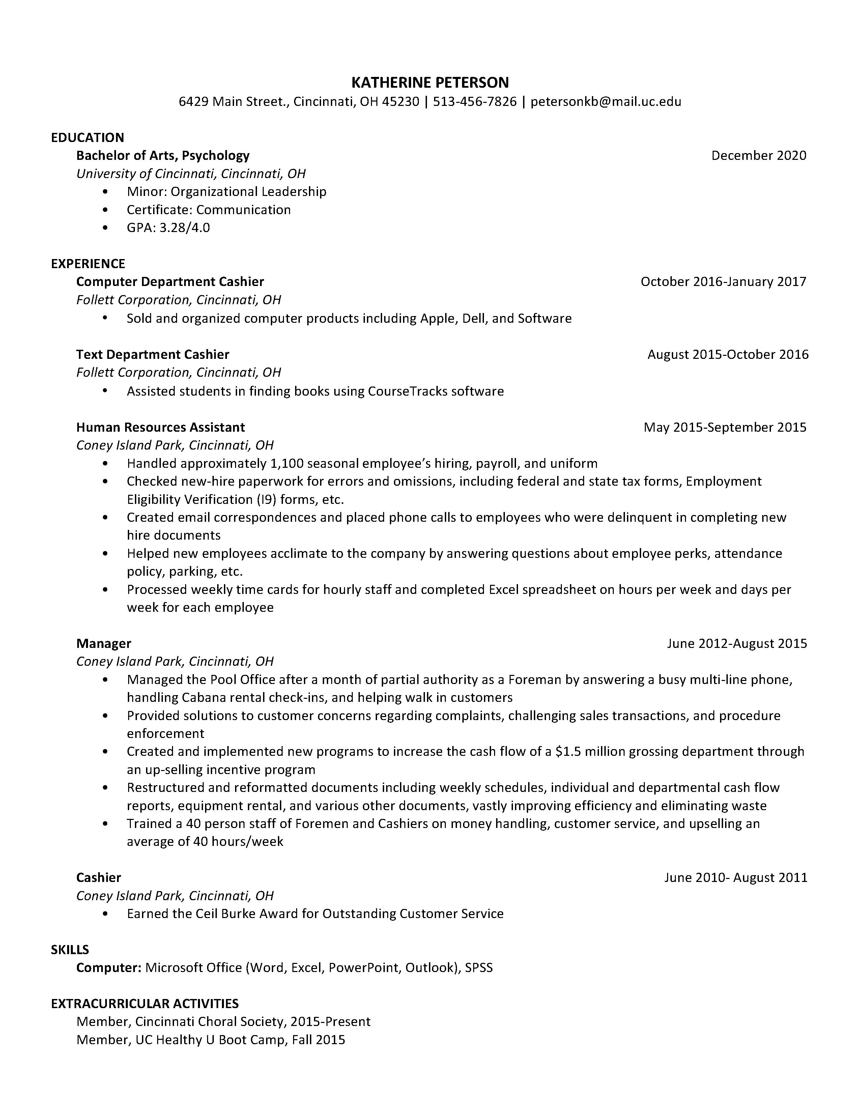

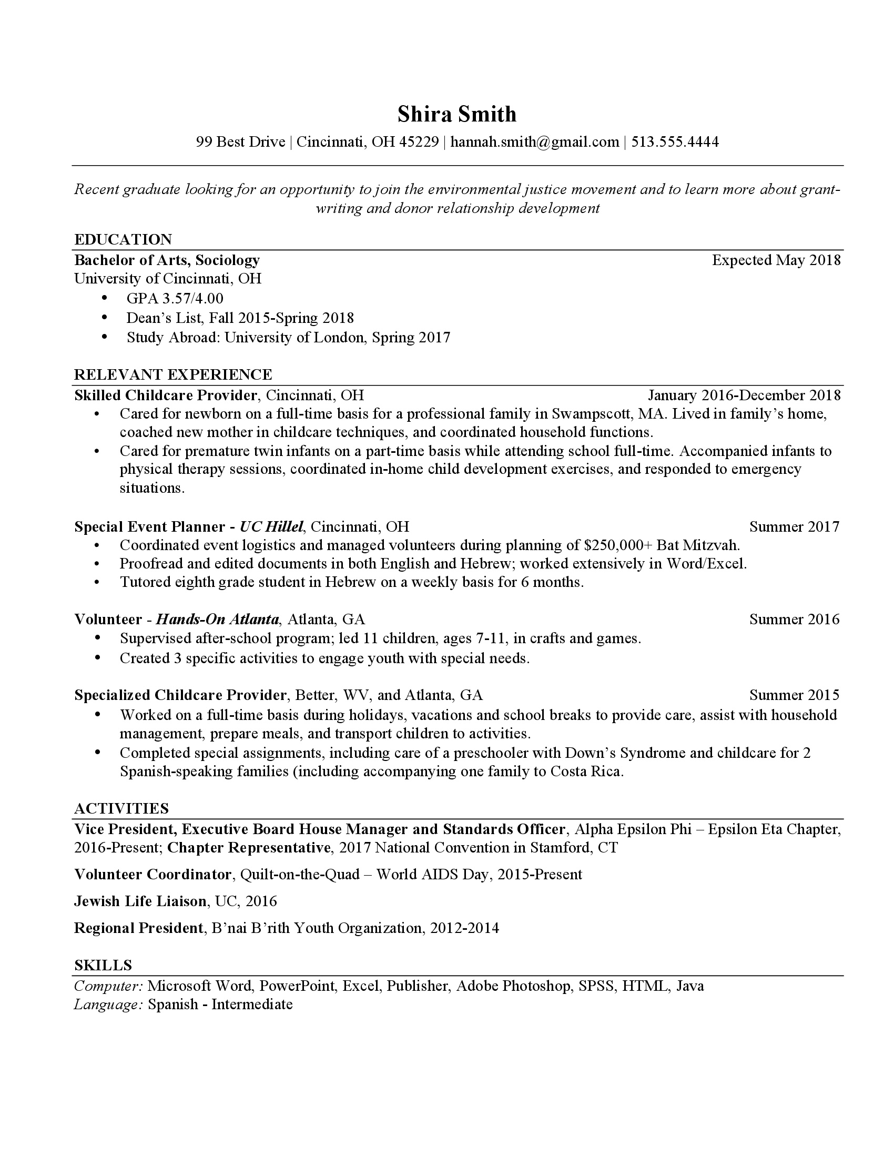

Step 2: Collect and Fill in Your Information
Make a list of all of your work and volunteer experiences, awards and scholarships, study abroad and training programs, student organizations, leadership roles, lab and computer skills, languages, and certifications. Be sure to use exact names for degrees, programs, organizations and titles – you may have to look some of them up online.

Then, fill in the template using the outlined sections below. Choose optional sections that capture your strengths and skills. Remember that many sections are flexible can be combined to tell your unique story.

Contact Information (Required)
- Name—slightly larger font than the rest of your document
- Your address (you can use your permanent or campus address or both)

Summary (Optional)
- If you choose to use a “summary” it should be specific to the industry and position—a vague summary can do more harm than good

Education (Required)
- Should be at the top of your resume if you are a recent grad
- Degree (Bachelor of Arts, Bachelor of Science, etc.) and month/year of graduation
- Major(s), and/or minor(s), and any concentration(s) within your major(s) or minor(s) if applicable
- University and location

Education (Optional)
- Relevant Courses may be added for classes related to the position, beyond general or introductory requirements of your major. This should include 3-5 courses, listed across the page, separating each name with a comma.
- Relevant awards and honors that you earned for academics, athletics, or in a work environment may be included under education or listed in a separate section at the end of the document.
- Other universities, if applicable, should be formatted the same as current university
- Include high school, for First and Second Year students, formatted the same as current university

Experience (Required)
- Always include job title, dates, name of organization, and location
- Address what you learned and the skills you developed in addition to the tasks/jobs you performed
- “Experience” can include clubs or project work in addition to jobs or employment

Leadership, Activities, and Service (Optional)
- Your resume may contain one or all of these sections and some can be combined, such as Activities and Service
- It is important to choose quality over quantity in this section. Only include experiences where you’ve developed skills relevant to the position

Skills (Required)
- This section typically includes computer, language, and science/laboratory when applicable
- It is preferred that you incorporate soft skills into your experiences to demonstrate how they were developed rather than simply listed in this section.

Interests (Optional)
- Certain industries may also like to see an “Interests” section that includes hobbies and areas of interests that could be discussed in an interview
- Interest sections can be combined with another section such as “Skills” or “Activities”

Step 3: Write Strong Descriptions to Emphasize Your Skills and Accomplishments
Your bulleted descriptions are the heart of your resume, because these go beyond a simple list of your “duties” at a job. Rather, they should communicate what you learned and accomplished in your roles that will help you excel in the position you are applying for.

Below are 3 suggestions for writing effective bullets:

Consider the Top Skills that Employers Seek in a Candidate

- Critical Thinking/Problem Solving: Exercise sound reasoning to analyze issues, make decisions, and overcome problems. The individual is able to obtain, interpret, and use knowledge, facts, and data in this process, and may demonstrate originality and inventiveness.
- Oral/Written Communications: Articulate thoughts and ideas clearly and effectively in written and oral forms to persons inside and outside of the organization. The individual has public speaking skills; is able to express ideas to others; and can write/edit memos, letters, and complex technical reports clearly and effectively.
- Teamwork/Collaboration: Build collaborative relationships with colleagues and customers representing diverse cultures, races, ages, genders, religions, lifestyles, and viewpoints. The individual is able to work within a team structure, and can negotiate and manage conflict.
- Digital Technology: Leverage existing digital technologies ethically and efficiently to solve problems, complete tasks, and accomplish goals. The individual demonstrates effective adaptability to new and emerging technologies.
- Leadership: Leverage the strengths of others to achieve common goals, and use interpersonal skills to coach and develop others. The individual is able to assess and manage his/her emotions and those of others; use empathetic skills to guide and motivate; and organize, prioritize, and delegate work.
- Professionalism/Work Ethic: Demonstrate personal accountability and effective work habits, e.g., punctuality, working productively with others, and time workload management, and understand the impact of non-verbal communication on professional work image. The individual demonstrates integrity and ethical behavior, acts responsibly with the interests of the larger community in mind, and is able to learn from his/her mistakes.
- Career Management: Identify and articulate one's skills, strengths, knowledge, and experiences relevant to the position desired and career goals, and identify areas necessary for professional growth. The individual is able to navigate and explore job options, understands and can take the steps necessary to pursue opportunities, and understands how to self-advocate for opportunities in the workplace.
- Global/Intercultural Fluency: Value, respect, and learn from diverse cultures, races, ages, genders, sexual orientations, and religions. The individual demonstrates openness, inclusiveness, sensitivity, and the ability to interact respectfully with all people and understand individuals’ differences.
[Source: National Association of Colleges & Employers]

Begin Each Bullet with an Action Verb
Bullet points should start with a powerful action verb, such as those listed below. Avoid starting bullet points with “Responsible for,” “Assisted with,” or “Primary duties included.”

Sample List of Action Verbs

accelerated accomplished achieved acquired adapted
adjusted administered advertised advised advocated
analyzed anticipated applied appraised approved arranged assembled assessed assisted assumed attained attended authored balanced briefed budgeted
built
calculated catalogued chaired changed checked circulated classified collaborated collected combined compiled completed computed condensed conducted consolidated constructed consulted converted convinced coordinated corrected counseled counted created defined delegated delivered demonstrated designed determined developed devised directed discovered dispatched displayed distributed drafted
earned
edited
elected eliminated employed encouraged enlisted ensured entered established estimated evaluated examined expedited explored extended facilitated familiarized filed
forecasted formulated fostered
gained gathered generated graded
greeted handled
helped highlighted identified illustrated implemented improved incorporated increased informed initiated innovated inspected inspired instructed interpreted interviewed inventoried invested investigated joined
judged
launched
learned
led
managed marketed maximized measured monitored notified
observed obtained
opened
operated orchestrated ordered organized participated persuaded planned prepared presented processed produced projected promoted proofed
proposed provided publicized published purchased received recognized recommended recorded recruited
reduced reorganized repaired replaced reported represented researched resolved restructured reviewed
revised
saved
scheduled screened
selected
sent
served
shipped
showed
sold
solved
sought
specified
spoke
sponsored
started stopped straightened streamlined strengthened studied
submitted suggested summarized supervised surpassed
taught
tested
trained transferred updated upgraded
utilized

Provide Details About What You Accomplished that Relate to the Position You Seek
Ask yourself, “What did I do?” “How did I do it?” and “Why did I do it?”

Begin with What? – What, specifically, did you do in your position?
- Answered telephones
- Planned an event
- Entered data into Excel

Think about How? –Review your list of tasks and ask yourself which skills you used when completing those responsibilities. Use numbers to quantify accomplishments wherever you can.
- Operated a multi-line phone for five busy attorneys utilizing effective problem-solving and customer service skills
- Coordinated an event for over 100 students through communication with on-site liaison
- Executed financial analysis of department spending in Excel

Incorporate Why?
This section helps the reader understand the purpose behind your actions and see what you accomplished in your role.
- Operated a multi-line phone for five busy attorneys utilizing effective problem-solving and customer service skills to ensure customer satisfaction
- Coordinated recognition event for over 100 students completing a certificate program through communication with on-site liaison
- Executed financial analysis of department spending plans in Excel and provided comprehensive written report to manager

Step 4: Carefully Review Your Resume
Since resumes involve a lot of detail and careful formatting, it is very easy to have mistakes. The last stage of developing your resume should include a meticulous review of your formatting and content, and a careful search for typographical errors. If possible, have a friend or family member conduct a final check of your resume.
Use the checklist below:

General Format
Yes No
❑ ❑ Is resume an appropriate length? (1 page)
❑ ❑ Is first and last name at the top of the page and in bold? Are address, phone number, and email easy to read?
❑ ❑ Does Education follow directly after the contact information?
❑ ❑ Is formatting (e.g. bold, font, bullet sizes, heading styles) consistent throughout the resume? Are the headings and statements evenly spaced? Are your dates evenly aligned along the right margin of the page?
❑ ❑ Are verb tenses present tense for current experiences; past for previous experiences?
❑ ❑ Are there approximately 1-4 statements in bulleted format under the Experience section?

Content
Yes No
❑ ❑ If included, does the Objective statement clearly state industry, position, and two to three skill sets?
❑ ❑ Does the resume include the applicable headings? Education, Experience, Activities/Leadership/Service, and Skills?
❑ ❑ Does the Education section state official degree and graduation date? Is the cumulative GPA included if higher than 3.0? Is my GPA accurate and not rounded up?
❑ ❑ Do the bulleted descriptions demonstrate major accomplishments rather than routine tasks/duties and are they quantifiable when possible?
❑ ❑ Do the bulleted descriptions start with action verbs and demonstrate the use of key skills?
❑ ❑ Is the resume free of personal pronouns (e.g. no references to “I,” “we,” “me,” “us,” or “my”)?
❑ ❑ Is the resume completely free from spelling, punctuation, abbreviations, and grammatical errors?

Step 5: Use Your Resume
Resumes are most commonly used to apply for open positions, but there are other ways you can leverage your resume to tell your story and market your skills.

Here are a few ideas:

Add Your Resume to an Online Portfolio or Personal Website
There are a number of professions that recommend using an online portfolio to showcase your work, principally art, design, consulting and public speaking. These sites often include a short biographical statement or resume.

Use Your Resume to Connect with Professionals in Your Field of Interest
Expanding your network is critical to professional success. When attending career fairs or networking events, always bring several copies of your resume. You can also tactfully share your resume when conducting informational interviews with professionals of interest (see our Informational Interviewing guide).

