2013 Edition
Developing Successful Academic Program Assessment:
A Workbook

For more information
Visit the CET&L website: www.uc.edu/cetl.html
Or contact: cetl@uc.edu

Use of “Developing Successful Academic Program Assessment: A Workbook” is restricted. This document may not be copied or duplicated without the written permission of the Center for the Enhancement of Teaching & Learning at the University of Cincinnati.

Table of Contents
Overview of Program-Level Assessment 2
Activity 1: Envision the Ideal Graduate 4
Activity 2: Define Student Learning Outcomes 6
Rubric for the Assessment of Program Outcomes 11
Activity 3: Curriculum Mapping Matrix 12
Activity 4: Conduct a Preliminary Audit of Assessment Methods Utilized in Your Program 17
Why Not Just Use Course Grades for Assessment Purposes? 21
Helpful Tips for Selecting Assessment Methods: 26
Activity 5: Alignment, Assessment, Measures and Program Outcomes. 29
Activity 6: Developing Your Assessment Infrastructure 34
Looking Forward: An Example Implementation of an Assessment Plan from Radiology 36
HOMEWORK: Revise your plan to gather, analyze, and interpret assessment data 37
Activity 7: Peer evaluation of drafted program assessment plan. 49
Glossary of Assessment Terms 55
Notes: 57

Overview of Program-Level Assessment

Identify and explain to colleagues the purpose and process of assessment, including how assessment data might be used to identify strengths, weaknesses, and gaps within a curriculum that can be addressed to improve student learning.

To explain the purpose and process of assessment, we have included two resources:
- PowerPoint Slides from the CET&L “Academic Program Assessment Support” workshop
- Why Are We Assessing?, the pre-workshop reading for the CET&L “Academic Program Assessment Support” workshop

Purpose of Assessment: “to provide students with the best possible education and ensure student learning is of appropriate scope, depth, and rigor” (Suskie 2012).
To inform this purpose, we will ask four questions:
- What have our students learned?
- Are we satisfied with what they have learned?
- If not, what are we doing about it?
- How do we know what they have learned?

Process of Assessment:
The answers to these questions will help frame the process of assessment, which includes five steps.

Activity 1: Envision the Ideal Graduate

When crafting student-learning outcomes for your program, there is no better place to begin than with the ideal end in mind, the end-of-program outcome. This opening module seeks to create a “blue sky” vision of your program’s outcomes. Before considering any limitations, constraints, or challenges, explore your greatest hopes for your graduates and their development.

The Task: Brainstorm the “ideal” graduate of your program. Be sure to describe how you imagine your ideal graduates once they become professionals in their field. You can type or write your responses in the boxes below.

What does an “ideal” graduate of your program look like? In a perfect world, how will your graduates think and behave? What “tools” – theories, concepts and techniques – will they be able to apply?

If these category listings are not applicable to your program, please insert alternative headings.
Thinking | Acting | Knowledge

Activity 2: Define Student Learning Outcomes

The Context: Program Outcomes (POs) are defined as: the knowledge, skills, or behaviors that a program’s students should be able to demonstrate upon program completion. The POs determined by your team will represent the big picture of your program, depicting broad aspects of desired student capabilities, encompassing multiple and varied learning experiences, and reflecting key criteria of your students’ transition from education to profession.

The Task: Using the vision of an ideal graduate from Activity 1, generate a list of student learning outcomes for your program.
- Phrase these outcomes to use higher-order thinking skills, such as “evaluating” or “analyzing.”
- Be sure you can measure or evaluate the outcome in some way.
- Make the outcomes concrete rather than abstract.
- Use active, rather passive, verbs so you specify who is doing what. Passive verbs hide who the actor is, so when specifying actions, active verbs are clearer.

Below are examples of program outcomes:

Bachelor Degree in Business (BBA) – Upon completion of the BBA Program, students will be able to:
- Apply functional and cross-functional knowledge to critically assess business problems.
- Use analyses to inform and develop integrative solutions that improve business outcomes.
- Express ideas clearly, logically and persuasively in both oral and written formats.
- Recognize ethical and social responsibility issues in a business environment and know how to apply a process of ethical inquiry.
- Show how operating in a global market creates business opportunities and challenges.
- Work cooperatively and effectively in a cross-disciplinary team

Bachelor Degree in Health Science (HLSC) –Upon completion of the HLSC Program, students will be able to:
- Plan, execute, evaluate, adjust physical activities and programs appropriate for self and clients
- Provide complete, understandable and accurate information within content areas to clients and community
- Develop and/or disseminate scientific information to the general public and the academic community
- Apply information from various basic and applied science disciplines in a manner that provides for efficient, effective and safe physical activities
- Investigate and evaluate the general state of public health conditions and concerns and develop and apply appropriate programs of action within program content area

Graduate program learning outcomes need to…

- Be progressively more advanced in academic content
- Address discipline knowledge and research or professional practice
- Address technology skill development (if appropriate)
- Be informed & aligned with professional organization standards, licensing bodies, or specialized accreditors
- Include professional development of graduate students
- Address disciplinary ethical standards

Example: Student Learning Outcomes at the Graduate Level

Upon completion of the physics PhD program, students will be able to:

- identify and describe the broad fundamental concepts of physics;
- analyze physics problems using fundamental physics concepts and appropriate mathematical models;
- solve physics problems using analytic, computational, observational, or experimental methods;
- present clearly organized oral explanations of physics topics at a level appropriate to the audience at hand;
- explain and analyze at an expert level the concepts and the state of current research in a subfield of physics;
- compose and defend written presentations of physics research in a format and at a level appropriate for journal publication;
- conceptualize, design, and implement new approaches for solving research problems in physics, including analytic, computational, observational, and experimental methods, as appropriate.

Activity 2: Draft Program-Based Student Learning Outcomes
Program Outcome #1
Program Outcome #2
Program Outcome #3
Program Outcome #4
Program Outcome #5
Program Outcome #6
Program Outcome #7

BLOOM’S TAXONOMY
Level | Definition | Sample verbs |  |  |  |  | Sample behaviors
KNOWLEDGE | Student recalls or recognizes information, ideas, and principles in the approximate form in which they were learned. | arrange  define  describe  duplicate | identify  label  list  match | memorize  name  order  outline | recognize  relate  recall  repeat | reproduce  select  state | The student will define the 6 levels of Bloom’s taxonomy of the cognitive domain.
COMPREHENSION | Student translates, comprehends, or interprets information based on prior learning. | explain  summarize  paraphrase  describe  illustrate  classify | convert  defend  describe  discuss  distinguish  estimate  explain | express  extend  generalize  give examples(s)  identify  indicate | infer  locate  paraphrase  predict  recognize | rewrite  review  select  summarize  translate | The student will explain the purpose of Bloom’s taxonomy of the cognitive domain.
APPLICATION | Student selects, transfers, and uses data and principles to complete a problem or task with a minimum of direction. | use  compute  solve  demonstrate  apply  construct | apply  change  choose  compute  demonstrate  discover  dramatize | employ  illustrate  interpret  manipulate  modify  operate | practice  predict  prepare  produce  relate  schedule | show  sketch  solve  use  write | The student will write an instructional objective for each level of Bloom’s taxonomy.
ANALYSIS | Student distinguishes, classifies, and related the assumptions, hypothesis, evidence, or structure of a statement or question | analyze  categorize  compare  contrast  separate  apply | change  discover  choose  compute  demonstrate  dramatize | employ  illustrate  interpret  manipulate  modify  operate | practice  predict  prepare  produce  relate  schedule | show  sketch  solve  use  write | The student will compare and contrast the cognitive and affective domains.
SYNTHESIS | Student originates, integrates, and combines ideas into a product, plan or proposal that is new to him or her | create  design  hypothesize  invent  develop  arrange  assemble | categorize  collect  combine  comply  compose  construct  create | design  develop  devise  explain  formulate  generate  plan | prepare  rearrange  reconstruct  relate  reorganize  revise | rewrite  set up  summarize  synthesize  tell  write | The student will design a classification scheme for writing educational objectives that combines the cognitive, affective, and psychomotor domains.
EVALUATION | Student appraises, assesses, or critiques on a basis of specific standards and criteria | judge  recommend  critique  justify  appraise  argue | assess  attach  choose  compare  conclude  contrast | defend  describe  discriminate  estimate  evaluate  explain | justify  interpret  relate  predict  value | rate  select  summarize  support | The student will judge the effectiveness of writing objectives using Bloom’s taxonomy.

Category | Problematic | Some questions | Adequate | Excellent
Student focus (that is, with students as the primary audience for the PO’s) | Little or no sense of any student audience, or inappropriate sense of audience, for all of the PO’s | Sense of other faculty as audience for some PO’s, minimal awareness of student perspective | Inclusion of students as audience although not in a consistent way; students and non-professionals may have difficulty with some terminology | Consistently and clearly student centered in its sense of audience; avoids jargon and defines key terms (such as “critical thinking”) to clarify expectations
Program level (within the overall curriculum) | PO’s are inappropriate for this particular curriculum | PO’s might be appropriate for this curriculum although not adequately clear on this point | PO’s are largely appropriate for this curriculum, although some of this match is still not fully specified | PO’s are fully and clearly appropriate for this curriculum
Mastery level (that is, the extent to which the learning should be mastered upon graduation) | Unclear sense of the level of mastery at which the learning should occur | Emerging but still unclear sense of the level of mastery at which student learning should occur | The main elements are clear about the level of mastery at which student learning should occur, although specific applications remain unspecified | Clearly defined and described set of expectations about the level of mastery that student learning should demonstrate
Observable and measurable behavior (to be observed and measured upon graduation) | Impossible to observe or measure any of the PO’s or to apply the learning in the curriculum through any activity | Possible to observe or measure some of the learning but not all; unclear how the levels of mastery are observable or measurable | Possible to observe or measure the main elements of the PO’s, but unclear how some areas will be observed or measured. Still not fully articulated how the student will apply the learning from the curriculum. | The PO’s are all clearly observable and measurable; the PO’s avoid terms such as “understands, values, and appreciates,” and instead uses terms such as “identifies, compares, or explains”
Overall evaluation of the PO’s | Missing PO’s, or unrelated to (or inappropriate for) the program curriculum description | PO’s are unclear or seem incomplete | PO’s are clearly written and also compatible with the program curriculum | PO’s are observable, measurable, and useful for both

Rubric for the Assessment of Program Outcomes

Developed by the Center for the Enhancement of Teaching & Learning at the University of Cincinnati (April 2013)

Activity 3: Curriculum Mapping Matrix

The next step is to identify the assessment of Program Learning Outcomes that are already occurring in your department. Wherever you are gathering information about student learning, even if it is informal, even if it is not written down, even if it is not being used very well, even if it no one has called it assessment, include it now, because it is a potential site or building block for assessment (see Assessment measure Inventory).

Where is Assessment Already Occurring?

Begin your audit by identifying where in your courses and experiences the program learning outcomes are being taught and assessed in your program (at the Emerging, Developed and Achieved levels). Although you may not know what each instructor is doing, you may have some ideas of what types of assessments are occurring. After this session, you can go back to your department and conduct of more extensive audit. Appendix A presents a matrix that each faculty member can complete for each required course/ experience taught, showing how he or she teaches and assesses Program Outcomes and, in the final example, identifying strengths and weaknesses the faculty members perceive in student work. This information on classroom assessment eventually will be included in the complete report on all assessment in the department.

Next, use the “Curriculum Mapping Matrix” to diagram where in your program (in what courses or experiences) your program outcomes are being addresses. This activity will help you verify the alignment of required courses with program learning outcomes and your program’s assessment methods.
NOTE: This activity asks you to use the Program Outcomes and required courses identified in your unit’s P-1. When you completed the P-1 form, you mapped course-level student learning outcomes to program level outcomes.
Instructions:
- Review the example curriculum map (page 14) completed for an English Department.
- On the blank curriculum map (page 15), list your program learning outcomes identified in the P-1 in the column labeled “Program Learning Outcomes.”
- List the required courses and experiences identified in the P-1 across the top row.
- Identify which course(s) utilizes each program learning outcome and at what level the program learning outcome is addressed (e.g. emerging, developed or achieved).

Curriculum Mapping Matrix: Linking Program Outcomes to Curriculum
Key | Required Courses / Experiences Identified in P-1
E: Emerging
D: Developing
A: Achieved
OUTCOMES  Outcome 1 | Course 1 | Course 2 | Course 3
1 | E, D | A
2  Outcome 3  Outcome 2 | E, D |  | A
3 | E | D | A
4
1. List your program outcomes from the P-1 here
3. Identify which course(s) utilizes each outcome and at what level (E, D, A).
* NOTE: multiple levels may be identified)
2. List your required courses from the P-1 here

REMEMBER: Each outcome must be addressed at each level (E,D,A).

Key
E = Emerging
D = Developing
A = Achieved
Program Learning Outcomes | Required Courses Identified in P-1
 | ANTH 1003 (Intro to Cult) | ANTH 1005 (Intro to Bio) | ANTH 1007 (Intro to Arch) | ANTH 1009 (Intro to Ling) | Methods (students choose 1 from list) | 4000+ plus (students choose 1) | Capstone
PLO 1: describe and discuss topics related to the four subfields of Anthropology (Biological, Cultural, Archaeology, and Linguistics) and to articulate approaches and issues associated with each. | E, D, A | E, D, A | E, D, A | E, D, A
PLO 2: Articulate the relevance of Anthropology in an increasingly globalized society | E | E | E | E |  | D | D, A
PLO 3: recognize and reflect on ethical and historical issues in anthropology and archaeology. | E | E | E | E | D, A | D, A | A
PLO 4: critically evaluate primary sources in anthropological literature using written and oral communication. |  |  |  |  | E, D, A | E, D, A | D, A

Curriculum Mapping Matrix: Linking Program Outcomes to Curriculum
Key | Required Courses and Experiences* Identified in P-1
E: Emerging
D: Developing
A: Achieved
OUTCOMES
1
2
3
4
5
6
7
8
9
NOTE: Do not list courses/experiences controlled by external academic units. Only list courses and experiences that are controlled by your program.

Activity 4: Conduct a Preliminary Audit of Assessment Methods Utilized in Your Program

For the second part of your audit, take an inventory of program assessment measures currently used in your academic unit; both direct and indirect.

Direct assessment measures: A direct measure is based on a sample of actual student work, including reports, exams, demonstrations, performances, and completed works. The strength of direct measurement is that faculty members are capturing a sample of what students can do, which can be very strong evidence of student learning. A possible weakness of direct measurement is that not everything can be demonstrated in a direct way, such as values, perceptions, feelings, and attitudes.

Examples of direct assessment measures would include: Capstone projects, exhibits, performances, portfolios, pass rates or scores on licensure or certification exams, Student publications or presentations, employer or internship, supervisors’ reports, External review (accreditation)

Indirect assessment measures:

An indirect measure is based upon a report of perceived student learning. The reports can come from many perspectives, including students, faculty, internship supervisors, transfer institutions, and employers. Indirect measures can provide additional information about what students are learning and how different constituencies value this learning. However, as evidence of student learning, indirect measures are not as strong as direct measures because we have to make assumptions about what exactly the self-report means. For example, if students report that they have attained a particular learning goal, how do we know that their report is accurate? The strength of indirect measurement is that it can assess certain implicit qualities of student learning, such as values, feelings, perceptions, and attitudes, from a variety of perspectives. The weakness of this approach is that, in the absence of direct evidence, assumptions must be made about how well perceptions match the reality of actual achievement.

Examples of indirect assessment measures would include: Focus group interviews with students, faculty, employers, Registration, enrollment, graduation, transfer data, Department self-study or program review data, Job placement data, Surveys, Employer, Alumni, Student perceptions

The Task:
Identify how each measure is used for departmental decision-making. Try to link the assessment measures directly to your Program Outcomes, or you simply have to list the assessment measures and decide later how they relate to the Program Outcomes. Identifying appropriate methods for your academic program assessment plan can be a challenging process. Such an exercise however is an essential step to ensure the success of the assessment process.
The following inventory of assessment methods, and although we have identified the major or most frequently used methods there may be others that you are using. Please note this is not an exhaustive list. Your program may use other assessment measures not mentioned here. These measures and descriptions can be entered using the blank space provided at the end of the inventory.
Using the “Inventory of Assessment Methods,” read through possible assessment measures and their associated descriptions. Circle any measures you are currently using in your academic program.
Assessment type | Description
Artifact | A student-produced product or performance that is used as evidence for some kind of assessment activity. Many of the more specific terms used elsewhere in this form are examples of artifacts or processes that would produce artifacts.
Alumni Surveys | Surveying department alumni can provide a wide variety of information about program satisfaction, how well students are prepared for their careers, what types of jobs or graduate degrees majors have gone on to obtain, starting salaries for graduates, and the skills that are needed to succeed in the job market or in graduate study.
Capstone Projects | A senior year experience that enables students to transition to a profession or graduate school and continue to pursue life-long learning and social responsibility. The capstone experience is designed to demonstrate proficiency in the Baccalaureate Competencies and in the content/skills of the program/major. As a culminating experience, the capstone should require interdisciplinary and contextual perspectives (determined by unit or major).
Clinical Performance | A demonstration that indicates how a hospital or physician office might provide some measure of care to its patients. The performance might indicate such features as guidelines, standards, or practices for particular clinical activities.
Competency Check | A checklist to evaluate students regarding where they are in terms of working effectively in their career. This may involve examination, milestone achievements (e.g. certification), internships, etc.
Content Analysis | Content analysis is a technique that looks at a group of students, such as majors in a program or department, and assesses samples of written work that are produced by this group.
Course-Enabled Assessment | Questions embedded in course assignments or exams to assess student-learning outcomes.
Critique | An analysis of something (such as a written work, a musical composition, a work of art, etc.) that assesses (criticizes) the work under consideration, commenting on the means of composition in addition to evaluating its quality.
Culminating Assignments | Culminating assignments offer students the opportunity to put together the knowledge and skills they have acquired in the major, provide a final common experience for majors, and offer faculty a way to assess student achievement across a number of discipline-specific areas.
Curriculum Analysis | Curriculum analysis involves a systematic review of course syllabi, textbooks, exams, and other materials to help clarify learning objectives, explore differences and similarities between course sections, and/or assess the effectiveness of instructional materials.
Dissertation | In-depth research and analyses demonstrating high scholarly achievement, independent original research and advancing a new point of view.
Employer Surveys | Employer surveys help the department determine if their graduates have the necessary job skills and if there are other skills that employers particularly value that graduates are not acquiring in the program.
ETS | Educational Testing Services (ETS) is a national educational testing and assessment organization. It makes available various standardized tests, including the GRE, TOEFL, Praxis test Series, CLEP, etc. Many of these tests can be taken at UC’s campus in the Testing Services office.
Exhibit | A public presentation or showcasing of a particular creative object or set of objects, such as a work of art or design and typically associated with some course- or program-based assignment. The exhibition often includes some accompanying information about the creation or function of the object(s).
Focus Groups | Focus groups are structured discussions among homogeneous groups of 6-10 individuals who respond to specific open-ended questions designed to collect data about the beliefs, attitudes, and experiences of those in the group.
Group Presentation | A presentation of showcasing of the results of a particular project that has been conducted by a group of students. The presentation might take place in a classroom, over the web, or to a non-academic organization and would typically present the results of a course-based assignment.
I-LEAP | I-LEAP is an assessment instrument used to gather observations of student learning outcomes and skills demonstrated in contextual learning environments. I-LEAP can be used in a wide variety of experiential learning contexts, including internships, service learning, and more.
Institutional Data | A variety of departmental and student data are routinely collected at the university level.
Lab Practical | A laboratory exercise that functions as an assessment of a student’s knowledge or lab skills. The format for this assessment would typically use materials common to the lab, with the student then asked to identify those materials, conduct some procedure with them, or otherwise demonstrate expertise.
NSSE | The National Survey of Student Engagement annually collects information at hundreds of colleges and universities about student participation in programs and activities that institutions provide for their learning and personal development. The results provide an estimate of how undergraduates spend their time and what they gain from attending college. NSSE provides participating institutions with a variety of reports.
Observations | Observation as a method of assessment is an unobtrusive tool that can yield significant information about how and why students learn. This may include making observations at relevant interactive events, such as classes, club meetings, or social gatherings.
Oral Defense | A presentation where students also respond to questions and defend an argument or result of scholarship.
Oral Presentation | A classroom presentation or showcasing of the results of a particular project that has been conducted by an individual student or by a group of students in fulfilling a course assignment. The presentation might take place in a classroom or over the web and would typically present the results of a course-based assignment.
Performance Assessment | Performance assessment uses student activities to assess skills and knowledge. These activities include class assignments, auditions, recitals, projects, presentations and similar tasks.
Portfolio Evaluation | A systematic and organized collection of a student's work that exhibits to others the direct evidence of a student's efforts, achievements, and progress over a period of time. The collection should involve the student in selection of its contents, and should include information about the performance criteria, the rubric or criteria for judging merit, and evidence of student self-reflection or evaluation.
Poster Presentation | A combination of text and graphics to make a visually effective presentation, typically as part of a public showcase of work. Such a presentation typically allows viewers to communicate with the presenter in a sharing of information that might lead to new research developments.
Pre/Post Testing | A test or assignment is given at the beginning of a course or program. A similar test or assignment is then given at the end to determine student improvement.
Qualifying Exam | A written or oral examination that establishes candidacy or other qualifications. Usually used for doctoral candidacy.
Recital | A performance in a musical and theatrical experience in student productions and professional shows.
Reflective Essays | Reflective essays may be used as an assessment tool to gauge how well students understand class content and issues.
SSI | The Student Satisfaction Inventory (SSI) measures student satisfaction and priorities, showing how satisfied students are as well as what issues are important to them.
Standardized and Local Test Instruments | These tests are developed by a subject area's professional association or by professional testing agencies. (e.g. GRE, language competency exams, certifications, etc.).
Student Papers and Projects | Samples of student work from a variety of courses are evaluated to see how well the students are meeting program knowledge and skills goals.
Student Surveys and Exit Interviews | Surveys and interviews ask students to respond to a series of questions or statements about their academic experience.
Syllabus Analysis | Syllabus analysis involves looking at the current course syllabus to determine if the course is meeting the goals and objectives that the instructor or department has set for it.
Thesis | A thesis presents original research, proposition and conclusions. Although often required of master’s degree students, undergraduate students might produce a thesis as well.
Transcript Analysis | Transcript analysis involves using data from student databases to explore course-taking or grade patterns of students.
Unit-specific Tests | Some units develop their own diagnostic exams and use them as part of outcomes assessment.

Why Not Just Use Course Grades for Assessment Purposes?

You may wonder why student course grades cannot be used as acedemic program assessment data. After all, you are already assessing students in courses; why not just use student grades as an indication of what our students know or can do?

While this logic may on the surface appear reasonable, there are actually several very important reasons why course grades are problematic indicators for program assessment. These include:

  - Letter grades are nominal values reflecting a summary of a student’s performance.
  - Grades are not an exact measurement of what students have and have not learned.
  - Grades do not measure achievement program outcomes, learning of specific skills or the capacity of the curriculum to achieve PO2
  - Grades reflect the evaluation practices, policies, and criteria of individual instructors.
- Faculty teaching the same course may teach different material.
- Faculty teaching the same course may emphasize different course outcomes
  - Grades reflect the evaluation practices, policies, and criteria of individual instructors

Example: Outcomes for an Undergraduate Economics Program

- Students should be able to identify, explain, and use economic concepts, theories, models; and data-analytic techniques.
- Students should be able to deliver effective presentations in which they combine visual communication design with oral arguments and/or the written word.
- Students should use investigative skills necessary for conducting original economic research and participating effectively in project teams.
- Students should be able to apply their economic tools to formulate positions on a wide range of social and economic problems and engage effectively in policy debates.

 | Courses
Program Outcome | E101 | E202 | E303 | E404
1. Students should be able to identify, explain, and use economic concepts, theories, models; and data-analytic techniques | E | D | A
2. Students should be able to deliver effective presentations in which they combine visual communication design with oral arguments and/or the written word. | E | D | A
3. Students should use investigative skills necessary for conducting original economic research and participating effectively in project teams. | E | D |  | A
4. Students should be able to apply their economic tools to formulate positions on a wide range of social and economic problems and engage effectively in policy debates | E D |  |  | D A

Measurements of Learning in E303 | Grade | Points Possible
Exam | 78 | 100
Assignment | 18 | 20
Quiz | 10 | 50
Oral Presentation | 98 | 100
Exam | 88 | 100
Attendance | 10 | 20
Total | 302 | 390
Course Grade: | 77% | C

A letter grade is a nominal value that provides an overall summary of a student’s performance. Salient and summative in nature, grades inform instructors about their students’ achievement and play a key role in any academic system. However, they have shortcomings when being used for the purposes of making informed improvements about a program if they are not clearly linked to a single major learning outcome and are not clearly delineated through the use of test rubrics.

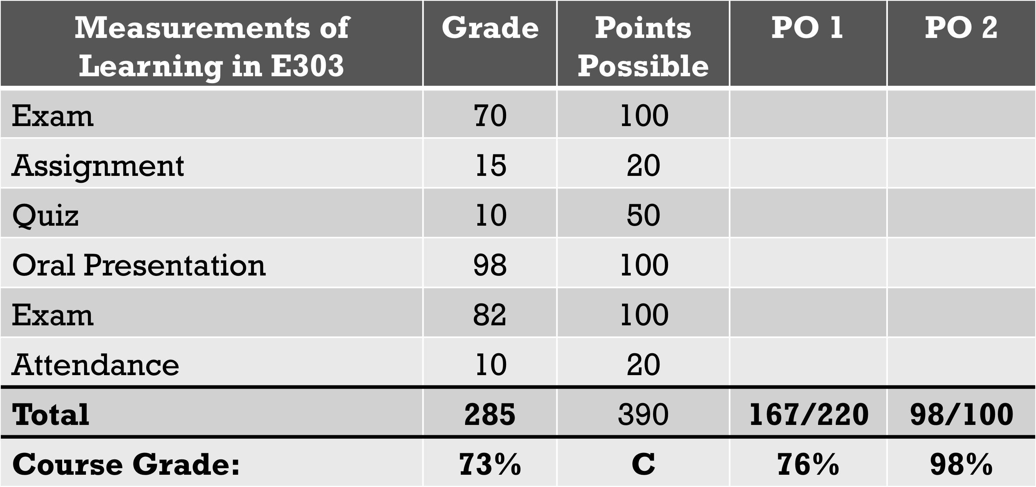

Measurements of Learning in E303 | Student 1 | Student 2 | Points Possible
Exam | 70 | 70 | 100
Assignment | 15 | 12 | 20
Quiz | 10 | 40 | 50
Oral Presentation | 98 | 50 | 100
Exam | 82 | 98 | 100
Attendance | 10 | 15 | 20
Total | 285 | 285 | 390
Course Grade: | 73% | 73% | C

The oral presentation assignment is worth 25% of the course grade.
It is possible for one student to get an exceptional grade on that assignment, and another to fail, with both students receiving a “C” for the final course grade.
The OVERALL course grade does not measure:
- Students’ demonstrated oral presentation skills
- The capacity of the curriculum to achieve PO2

Why aren’t course grades adequate indicators for program assessment?

Grades represent the extent to which a student has successfully met the faculty member's requirements and expectations for a course. Because many factors contribute to an assigned grade, it is almost impossible to make inferences about what a student knows or can do by only looking at the grades for a course.

Grades represent the extent to which a student has successfully met the faculty member's requirements and expectations for a course. Because many factors contribute to an assigned grade, it is almost impossible to make inferences about what a student knows or can do by only looking at the grades for a course.

Course letter grades are insufficient for program assessment because:
Instructor 1

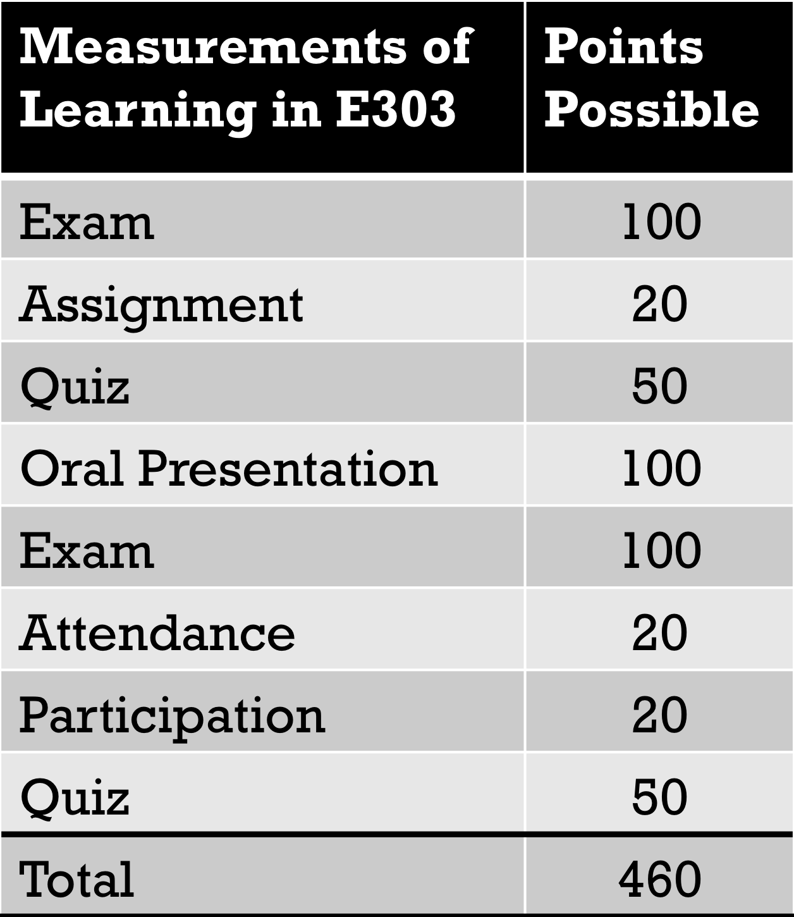
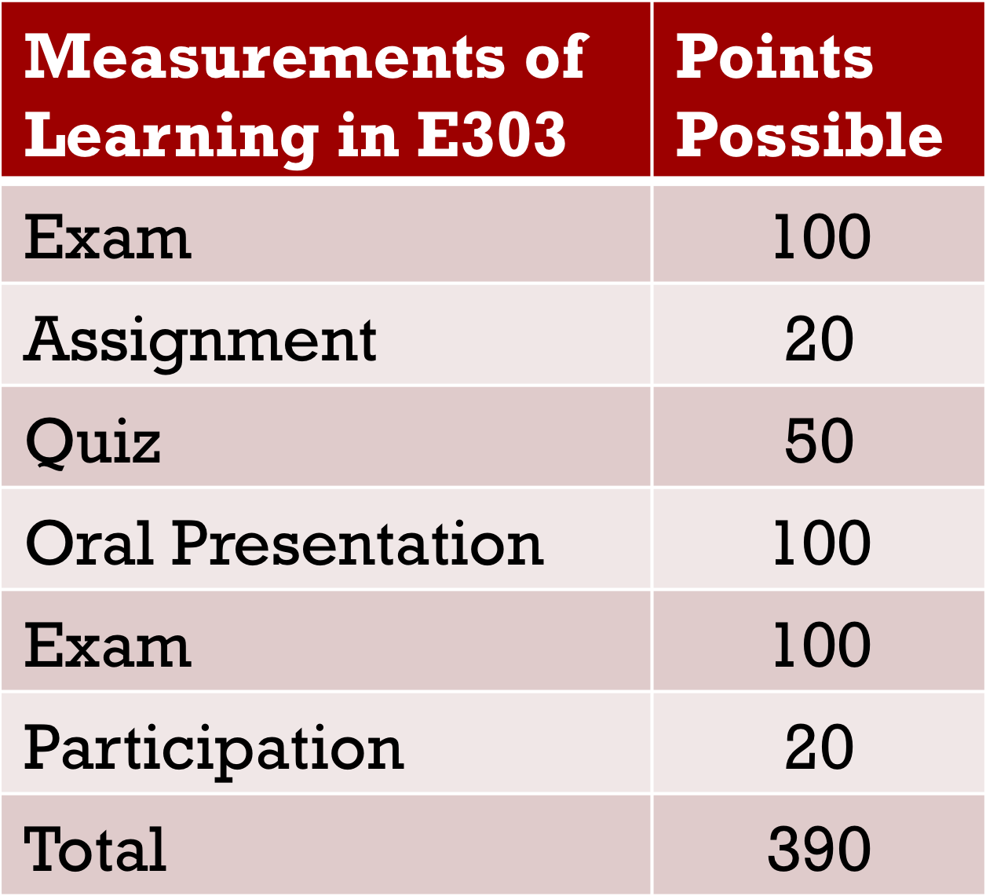
Instructor 2
Difference of 70 points between two sections of the same course!

What CAN Be Used from Courses for Program-level Assessment?

- Specific grades that reflect a specific PO
- An exam
- Assignment
- Oral presentation

Then the corresponding scores can be used to represent students' learning achievement on the PO, which can serve as data for program assessment.

Conditions for Using Course Products as Assessment Measures:

- All sections of the required course must produce the course product (e.g. an oral presentation)
- Faculty must agree on product structure (e.g. directions, requirements)
- Faculty must agree on how the products should be evaluated:
    - Minimum performance standards
    - Rubric

Average Program Score: 78/100

Take Home Message
Course products (cases, papers, presentations, exercises) may be used as program assessment measures, but course grades alone cannot.

Helpful Tips for Selecting Assessment Methods:

Select assessment methods that ensure the effectiveness of a program. A primary goal of assessment is to identify issues that, when addressed, will lead to improved student learning, retention and graduation rates. These methods and measures do not need to be complex, but only need to provide data that can be easily interpreted and are not ambiguous.

Choose assessment methods that will provide useful information. The intended outcome that is being assessed should allow one to make inferences about student progress. Assessing curricular requirements, the achievement of a goal, or the completion of an activity may not provide the type of evidence about student achievement, student support services or teaching practices that would provide opportunities for improvement.

Example of assessment method that will not provide useful, useable information:

Outcome: Students completing the Hypothetical Engineering program will demonstrate competence in conducting research.

Assessment method: all graduates will complete the Senior Design project.

Why this does not work: An element of Senior Design is that students complete a research project. Therefore, using the Senior Design project as an assessment of a student’s ability to conduct research does not provide any new information. It would be more effective to develop a scoring rubric for the design project and, with the data from the rubric; one would be equipped to analyze components of the design project. The data could then be analyzed and areas of weakness may be identified. These weak areas would then become the focus for improvement.

The importance of matching the assessment method to the learning outcome cannot be over stated. Successful and useful assessment can be achieved only if you align the assessment method with the outcome that you are trying to assess.

Example of an assessment method that does not match the learning outcome:

Outcome: Students completing the Hypothetical Engineering program will demonstrate competence in engineering principles comparable to graduates of other similar national programs.

Assessment method: This will be evaluated by giving students a locally developed exam.

Why this does not work: When comparing graduates of a program to other graduates nationally, using locally developed test as the assessment method is not recommended.

Example of an assessment method that matches the learning outcome:

Outcome: Students completing the Hypothetical Engineering program will demonstrate competence in engineering principles comparable to graduates of other similar national programs.

Assessment method: Students will equal or exceed the national average on the FE examination, administered twice a year.

Why this works: A more appropriate assessment method to compare the achievements of your graduates to the national average is to use a national instrument.

Select methods that provide information that can be directly controlled by the department or program. An assessment method that is influenced by external factors beyond the control of the program will yield results that may be meaningless because you may not be able to separate the impact of the department from the effects of those factors.

Multiple assessment measures are required for each intended learning outcome. The concepts and knowledge that address each outcomes passes through multiple learning phases, Emerging, Developed and Achieved, each of which need to be assessed to ensure the quality of learning that is occurring. Some benefits of using more than one method are that different components of one outcome can be assessed and a high level of accuracy and authority can be achieved.

Strive to identify subcomponents of a measurement approach so that you will be able to conduct a deeper analysis. In other words, include questions on a survey that measure components of an outcome (e.g., components of the quality of advising). Specific questions on a questionnaire can assess several aspects of overall quality (e.g. timeliness, accuracy, completeness of information). When using a survey with a small population (e.g. some graduate programs), it is desirable to target the entire group versus a sample. If you are unsure, contact CET&L for support.

The strengths and weaknesses of your program should be assessed. Select assessment methods accordingly. Exclusively assessing what already works will not provide you with the opportunity to implement changes that result in continuous improvement.

When possible utilize a combination of qualitative and quantitative assessment methods to effectively assess learning outcomes. The selection of assessment methods should reflect the culture of the program. Each type of assessment method selected should be one that provides decision makers with useful information. Examples of qualitative assessment methods include surveys, focus groups, exit interviews, case studies.

Utilize a combination of direct and indirect assessment methods. Some assessment methods require interaction with the students in an evaluative or instructional setting, while others do not (e.g., information from the student database or employer surveys).

Capstone courses and senior projects are an excellent method for directly assessing student learning. These methods promote interaction between faculty and students and “scholarly inquiry.” Additionally, they provide the students an opportunity to demonstrate the ability of absorbing, applying and integrating experiences and knowledge.

Before investing time and resources devising and developing new assessment instruments or methods, identify assessment processes already in place and assessment-related data that you are already collecting.

(Adapted from Auburn University; Hatfield, 1999; PACT; UCF OEAS website; University of Central Florida website and U.Mass. handbook)

Activity 5: Alignment, Assessment, Measures and Program Outcomes.

- Next, list your revised program learning outcomes in Assessment Measures Alignment Matrix on the following page in the column labeled “Program Learning Outcomes”.
Using the Program assessment measures identified in the previous step, match the assessment tool to the Program outcome (please note that that same assessment may be used for multiple program outcomes).
Enter these in the table on the following page under the column labeled “Assessment Methods” and next to the program outcome to which they apply.

- Next, for each of the types of assessment measures you listed in your Assessment Measures Alignment Matrix you will describe in the adjacent columns where (what courses), when/how often the data will be collected (timeline), and who is responsible for collecting, reviewing and making recommendations about the data.

You will use the Assessment Measures Alignment Matrix on page 32 to complete this activity.

When filling in this section keep the following in mind:

- Are the chair and/or departmental committees or directors of undergraduate/graduate studies reviewing data and making recommendations to the department? Should they?
- Are they reviewing all relevant data?
- Is the review sufficiently systematic?
- Do they have all the information they need for good decision-making?
- Does the department have the appropriate committees in place for addressing student learning?
- Are centralized data from Institutional Research, Career Placement, and similar offices appropriately used in the department?

You may find it helpful to refer to the example of a departmental assessment plan for Anthropology on the next page.

Assessment Measures Alignment Matrix
Program  Outcome | Assessment Measures | Course/ Experience | Time Line | Responsible Person

EXAMPLE: ANTHROPOLOGY Assessment Measures Alignment Matrix
Program Outcome | Assessment Tool | Course(s) where Data is collected and level (E, D, A) | Timeline | Person Responsible
Describe and critically discuss topics related to the four subfields of Anthropology (Cultural Anthropology, Biological Anthropology, Archaeology, and Linguistics) and to articulate approaches and issues associated with each. | A standard assignment (unique to each of the four courses) will be given each time the course is taught to assess at the “E” and “D” stages.  A standard set of questions (unique to each of the four courses) will be included on the final exam to assess at the “A” stage | ANTH 1003 (E, D, A)  ANTH 1005 (E, D, A)  ANTH 1007 (E, D, A)  ANTH 1009 (E, D, A) | Every term  Annual summary to inform changes for upcoming academic year  Major changes every 4-5 years | Members of the Curriculum Committee, Program Coordinator
Articulate the relevance of Anthropology in an increasingly globalized society. | A standard assignment (unique to each of the four courses) will be given each time the course is taught to assess at the “E” stage.  Students will complete two written assignments (graded according to a standardized rubric that examines content and focus, organization, writing style, and grammar/spelling) to assess at the “D” and “A” stages | ANTH 1003 (E), ANTH 1005 (E)  ANTH 1007 (E)  ANTH 1009 (E)  4000+ courses (D)  Capstone (A) | Every term  Annual summary to inform changes for upcoming academic year  Major changes every 4-5 years | Members of the Curriculum Committee,  Program Coordinator
Recognize and reflect on ethical and historical issues in Anthropology and Archaeology. | A standard assignment (unique to each of the four courses) will be given each time the course is taught to assess at the “E” stage.  Students will complete one written assignment (graded according to a standardized rubric that examines content and focus, organization, writing style, and grammar/spelling) to assess at the “D” stage  Students will complete one written assignment (graded according to a standardized rubric that examines content and focus, organization, writing style, and grammar/spelling) to assess at the “A” stage | ANTH 1003 (E), ANTH 1005 (E), ANTH 1007 (E), ANTH 1009 (E), Methods (D, A), 4000+ courses (D, A)  Capstone (A) | Every term  Annual summary to inform changes for upcoming academic year  Major changes every 4-5 years | Members of the Curriculum Committee,  Program Coordinator
Critically evaluate primary sources in anthropological literature using written and oral communication. | Students will complete a written assignment that requires them to identify primary sources related to a question of interest and summarize the findings/discussions in these sources. This will be graded according to a standardized rubric that examines appropriateness of source (e.g. article in Science vs. Wikipedia entry), relevance to the question at hand, and understanding of the article. This assignment will assess at the “E” stage.  Students will complete one written research paper and one oral presentation that compare and contrast multiple primary sources related to a question of interest. These will be graded according a standardized rubric that examines content, presentation style, organization, understanding of material, and grammar. These will be used to assess at the “D” and “A” stages. | Methods (E, D, A) 4000+ courses (E, D, A)  Capstone (D, A) | Every term  Annual summary to inform changes for upcoming academic year  Major changes every 4-5 years | Members of the Curriculum Committee,  Program Coordinator
Apply theoretical and methodological knowledge in field and laboratory contexts by collecting, organizing, analyzing, and interpreting qualitative and quantitative data. | Standard assignments and/or lab practicals in the Methods and 4000+ courses will be used to assess at the “E” and “D” stages. While these will vary from course to course (e.g., lab practicals in Human Location will be quite different from those in  Field Archaeology of the Southwest), assignments and practicals will be constructed so that they address 4 key areas: correct application of relevant methodology, correct identification of lab materials, data collection and interpretation.  Students will complete a research paper/project in order to assess at the “A” level. These papers/projects will be graded according to a standard rubric that examines the quality of data collected, organization and presentation of data, data analyses, data interpretation, and grammatical/stylistic issues. | Methods (E, D, A) 4000+ courses (E, D, A)  Capstone (D, A) | Every term  Annual summary to inform changes for upcoming academic year  Major changes every 4-5 years | Members of the Curriculum Committee  Program Coordinator

Activity 6: Developing Your Assessment Infrastructure

The Task:

- First, identify Personnel responsible for managing your program’s assessment plan as well as those who will be involved in data collection and consultation. You may find the following questions helpful to guide you through this process:

Who will chair/serve on the assessment committee? ______________________________________________ _________________________________________________________________________________________________________
_________________________________________________________________________________________________________
_________________________________________________________________________________________________________

What is the responsibility of the committee? _______________________________________________________ _________________________________________________________________________________________________________
_________________________________________________________________________________________________________
_________________________________________________________________________________________________________

How will data be collected, what will the submission process and form look like? _______________ _________________________________________________________________________________________________________
_________________________________________________________________________________________________________
__________________________________________________________________________________________________________________________________________________________________________________________________________________

When will review of data occur? (recommended annually) _______________________________________ _________________________________________________________________________________________________________
_________________________________________________________________________________________________________
_________________________________________________________________________________________________________

Explain the process of making curricular changes based on assessment findings and what the process of decimation/discussion of findings/recommendations will be.__________________________ _________________________________________________________________________________________________________
_________________________________________________________________________________________________________
_________________________________________________________________________________________________________

Will the course syllabi be collected? Will there be discussions with individual faculty regarding required courses in the curriculum? Explain. _______________________________________________________ _________________________________________________________________________________________________________
_________________________________________________________________________________________________________
_________________________________________________________________________________________________________

What will the recognition of service-load look like? ________________________________________________ _________________________________________________________________________________________________________
_________________________________________________________________________________________________________
_________________________________________________________________________________________________________

- Next, describe the timeline or Assessment Schedule for your academic program.
How often will data be collected.

When will faculty be reminded that data will be collected (recommended beginning of term)? _________________________________________________________________________________________________________ _________________________________________________________________________________________________________
_________________________________________________________________________________________________________
_________________________________________________________________________________________________________

How will faculty be reminded to submit data at end of term? _____________________________________ _________________________________________________________________________________________________________
_________________________________________________________________________________________________________
_________________________________________________________________________________________________________

What will be the schedule of data compilation, summary and review by PC?_____________________ _________________________________________________________________________________________________________
_________________________________________________________________________________________________________
_________________________________________________________________________________________________________

What will be the timeline for when these findings with be shared & discussed with department faculty_________________________________________________________________________________________________ _________________________________________________________________________________________________________
_________________________________________________________________________________________________________
_________________________________________________________________________________________________________

Will there be follow-up discussion with faculty teaching required courses and/or overseeing required experiences? Explain. ______________________________________________________________________ _________________________________________________________________________________________________________
_________________________________________________________________________________________________________
_________________________________________________________________________________________________________

What will be the timeline for improvement strategies identified (both short and long-term)? _________________________________________________________________________________________________________ _________________________________________________________________________________________________________
_________________________________________________________________________________________________________
_________________________________________________________________________________________________________

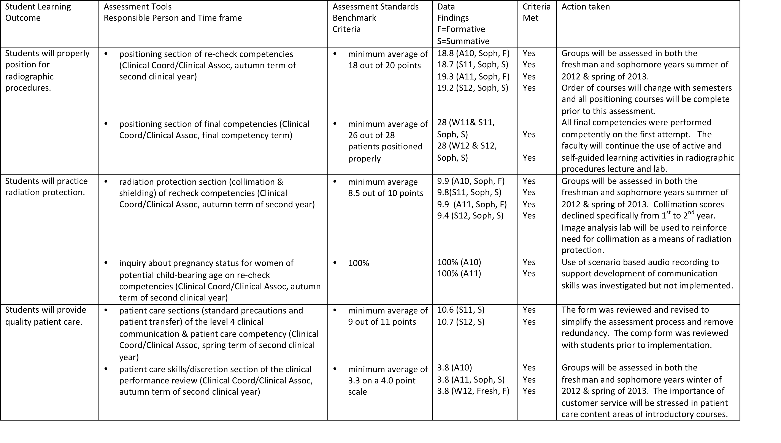
Looking Forward: An Example Implementation of an Assessment Plan from Radiology

HOMEWORK: Revise your plan to gather, analyze, and interpret assessment data

In preparing the Program Assessment Plan for your particular program, you might find the following template useful as a guideline, since it maps out the information that would typically be needed by the Academic Committee reviewers. We suggest using the six boldface items as headings within your own document.

- Program Outcomes
- Curriculum/Program Map
- Methods and Measures
- Assessment Infrastructure
- Findings
- Use of Findings

Using these headings, this Template lays out the framework for an Assessment Plan using a process that aim to conduct assessment and evaluation of academic program learning outcomes. This process is based on the steps and exercises you have completed so far in this workbook.

You will need:
- Program outcomes identified in the P-1
- Required courses identified in the P-1
- “Curriculum Mapping Matrix” completed in Activity 3
- “Assessment Measures Alignment Matrix” completed in Activity 5

- Review the “Creating An Assessment Plan” rubric on page 50 of this workbook.
- Review the “Academic Program Assessment Plan Template” on page 40 of this workbook.
- Using the “Academic Program Assessment Plan Template”, insert the appropriate documents from the activities completed during this institute.

This template also relies upon information in the FAQ document – see, for instance, answers to the fourth and fifth questions there – which might further clarify and simplify your Program Assessment Plan. The page for “Program Assessment Support” on the CET&L web site also has resources and information that might be useful.

Program

Department

College

Year

Primary Faculty:
Name
Phone
Email

Faculty Committee:
Member Name
Phone
Email

Member Name
Phone
Email

Member Name
Phone
Email

Member Name
Phone
Email

Member Name
Phone
Email

- Program Outcomes
Please include in this section your program learning outcomes as they are listed in the P-1 form in eCurriculum. If you are already planning to revise those program learning outcomes, indicate in this section which ones might be changed, and what the new program learning outcomes are likely to be. In general, learning outcomes should be measurable, assessable, or observable in some way and aligned with national standards.

- Curriculum/Program Map
Please include in this section a grid that identifies connections that exist between required courses in this program and the corresponding program-level learning outcomes. In other words: how will program outcomes be met? This grid should further indicate the expected levels of learning at each level (whether emerging, strengthening, or achieved). The CET&L web site includes templates that you might find useful in completed this grid.

Electronic versions of the Curriculum Map Template area available as BOTH Word and Excel file on the CET&L website.
Curriculum Mapping Matrix: Linking Program Outcomes to Curriculum
Key | Required Courses and Experiences* Identified in P-1
E: Emerging
D: Developing
A: Achieved
OUTCOMES
1
2
3
4
5
6
7
8
9
NOTE: Do not list courses/experiences controlled by external academic units. Only list courses and experiences that are controlled by your program.

- Methods and Measures
Please include in this section a description of the assessment methods that your program plans to use in assessing each of its program learning outcomes. These methods ideally include both direct and indirect examples of student learning, with authentic, performance-based assessment performed at all levels. You may find it helpful to include the “Assessment Measures Alignment Matrix” from Activity 5.

Electronic versions of the Assessment Measures Alignment Matrix Template area available as BOTH Word and Excel file on the CET&L website.

Assessment Measures Aligned with Program Outcomes
Program | Assessment Tools | Course/ Experience | Time Line | Responsible Person
Outcome | Responsible Person, Course(s) and Time frame

- Assessment Infrastructure
Please include in this section a description of the process by which your program intends to assess its learning outcomes.
- Describe which program faculty will be charged with overseeing the execution of the assessment plan as well as the ways in which they will carry out that charge, including a description of the planned timeline for assessment.
- Identify what kinds of administrative support will be available for those faculty
Please note that assessment plans should be capable of producing reports annually based on their review of the relevant data from their programs. The work of your faculty might also be coordinated and aligned with similar assessment efforts at the college and institutional levels.

Additionally, your program should plan to meet and collaborate with external units who provide courses that are required (but not controlled) by your department. Such collaborations will help to ensure alignment of expectations between your program and external units.

You may find it helpful to include or refer to your answers from from Activity 6: Developing Your Assessment Infrastructure.

- Findings
Here you will describe and explain in this section any multi-year patterns and trends that your assessment efforts have identified, including a description of any relevant relationships to national standards.

- Use of Findings
In this final section, you will describe how your program intends to make use of the program-level assessment data it has gathered.
- How will this information be presented to and discussed among the faculty?
- How might this data or these discussions result in review and possible revision of course or program learning outcomes and pedagogical strategies?

Activity 7: Peer evaluation of drafted program assessment plan.

For this last step you will apply the “Creating an Assessment Plan” rubric to a colleague’s assessment plan, to by providing peer evaluation using the foundational components of a strong assessment plan.

- Review the “Creating an Assessment Plan” rubric located on page 47.

- Program outcomes
- A curriculum/program map
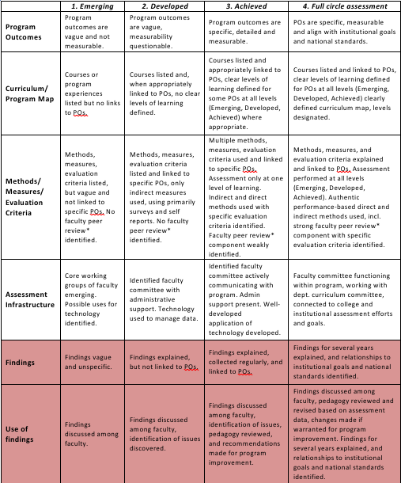
- Assessment method/measures
- An assessment infrastructure
- Assessment findings
- Use of findings

Creating An Assessment Plan Rubric

 | 1. Emerging | 2. Developed | 3. Achieved | 4. Full circle assessment
Program Outcomes | Program outcomes are vague and not measurable. | Program outcomes are vague, measurability questionable. | Program outcomes are specific, detailed and measurable. | POs are specific, measurable and align with institutional goals and national standards.
Curriculum/ Program Map | Courses or program experiences listed but no links to POs. | Courses listed and, when appropriately linked to POs, no clear levels of learning defined. | Courses listed and appropriately linked to POs, clear levels of learning defined for some POs at all levels (Emerging, Developed, Achieved) where appropriate. | Courses listed and linked to POs, clear levels of learning defined for POs at all levels (Emerging, Developed, Achieved) clearly defined curriculum map, levels designated.
Methods/ Measures/  Evaluation Criteria | Methods, measures, listed, but vague and not linked to specific POs. No faculty peer review* identified. | Methods, measures, listed and linked to specific POs, only indirect measures used, using primarily surveys and self reports. No faculty peer review* identified. | Multiple methods, measures, evaluation criteria used and linked to specific POs. Assessment only at one level of learning. Indirect and direct methods used. Faculty peer review* component weakly identified. | Methods, measures, and evaluation criteria explained and linked to POs. Assessment performed at all levels (Emerging, Developed, Achieved). Authentic performance-based direct and indirect methods used, incl. strong faculty peer review* component.
Assessment Infrastructure | Core working groups of faculty emerging. Possible uses for technology identified. | Identified faculty committee with administrative support. Technology used to manage data. | Identified faculty committee actively communicating with program. Admin support present. Well-developed  application of technology developed. | Faculty committee functioning within program, working with dept. curriculum committee, connected to college and institutional assessment efforts and goals.
Findings | Findings vague and unspecific. | Findings explained, but not linked to POs. | Findings explained, collected regularly, and linked to POs. | Findings for several years explained, and relationships to institutional goals and national standards identified.
Use of findings | Findings discussed among faculty. | Findings discussed among faculty, identification of issues discovered. | Findings discussed among faculty, identification of issues, pedagogy reviewed, and recommendations made for program improvement. | Findings discussed among faculty, pedagogy reviewed and revised based on assessment data, changes made if warranted for program improvement. Findings for several years explained, and relationships to institutional goals and national standards identified.
*Formative evaluations of the efforts of an individual colleague, unit, school, or college with the primary purpose to address and improve teaching strategies and curricular concerns, build intra- and interdisciplinary strength and support among diverse colleagues and disciplines, and represent and showcase differing problem-solving strategies and approaches that may impact teaching, research, and service.

Activity 7: Peer evaluation of drafted program assessment plan (Continued).

- Apply the “Creating an Assessment Plan” rubric to the first four components (e.g. program outcomes, curriculum/program map, assessment methods/measures, assessment infrastructure) of your collogues draft assessment plan.

- While applying the rubric to your colleague’s draft assessment plan, if you find that a category does not meet the standard of “4. Full Circle Assessment” provide recommendations to improve it? Please write the overall score and recommendations for improvements in the space below:

Score and Recommendations:

Program Learning Outcomes (POs): ______________________________________________________________________________________________________________________________________________________________________________________________________________________________________________________________________________________________________________________________________________________________________________________________________

It is possible to evaluate outcome measures by asking the three following questions. If faculty and chairs are able to answer, “yes” to all of three questions, it is likely that a strong set of measures has been developed.

- Review your collogues drafted assessment measure proposed for evaluating each outcome

- Answer the following questions to help provide peer feedback and recommendations to improve it? Please write recommendations for improvements in the space below:

Does the measure provide sufficient data and information to analyze the learning outcome?
__________________________________________________________________________________________________________________________________________________________________________________________________________________________________________
__________________________________________________________________________________________________________________________________________________________________________________________________________________________________________
__________________________________________________________________________________________________________________________________________________________________________________________________________________________________________
__________________________________________________________________________________________________________________________________________________________________________________________________________________________________________

Does the measure require a reasonable amount of work to collect?
__________________________________________________________________________________________________________________________________________________________________________________________________________________________________________
__________________________________________________________________________________________________________________________________________________________________________________________________________________________________________
__________________________________________________________________________________________________________________________________________________________________________________________________________________________________________
__________________________________________________________________________________________________________________________________________________________________________________________________________________________________________

Does the measure establish performance standards to help guide the analysis?

__________________________________________________________________________________________________________________________________________________________________________________________________________________________________________
__________________________________________________________________________________________________________________________________________________________________________________________________________________________________________
__________________________________________________________________________________________________________________________________________________________________________________________________________________________________________

Glossary of Assessment Terms

Assessment
The systematic collection, review and use of information about education programs undertaken for the purpose of improving learning and development. (Palomba & Banta, Assessment Essentials: Planning, Implementing, and Improving Assessment in Higher Education. San Francisco: Jossey-Bass, 1999, p. 4).

Assessment methodology
The study of and theory behind assessment methods.

Assessor
A person who evaluates the merits, importance, etc., of an educational program.

BoK (Breadth of Knowledge)
Part of UC's undergraduate General Education requirements, which include courses in diversity and culture, social and ethical issues, technology and innovation, quantitative reasoning, fine arts, historical perspectives, humanities and literature, natural sciences, and social sciences.

Criteria
This is a statement of the specific standards that demonstrate successful achievement of the intended outcome. It includes the following elements: data that will be used, who will demonstrate achievement, and when, under what conditions, and to what degree the demonstration will occur.

Curriculum map
A tool used to validate the cohesiveness of program curricula. It often appears in spreadsheet form and is constructed electronically.

Data source/measure
The specific place information will be gathered from, and in what way will it be measured.

Direct method of assessment
These immediately observable indicators of learning such as pre-post testing, oral examinations, internships, portfolio assessments, standardized national exams, locally developed tests, performance on licensure, certification, or professional exams, and juried reviews and performances.

Evidence
The available body of information indicating whether something is true or valid.

Faculty Peer Review:
Formative evaluations of the efforts of an individual colleague, unit, school, or college with the primary purpose to address and improve teaching strategies and curricular concerns, build intra- and interdisciplinary strength and support among diverse colleagues and disciplines, and represent and showcase differing problem-solving strategies and approaches that may impact teaching, research, and service.

Formative assessment
On-going assessments, reviews, and observations in a classroom.

Grading
Measurements of varying levels of comprehension, knowledge, competency and achievement within a subject area.

Grading vs. Assessment
In general, the goal of grading is to evaluate student learning and performance, and the goal of assessment is to improve student learning and evaluate program outcomes. Grades are the descriptive faculty evaluation of individual student performance via tests, assignments, projects, etc. Assessment evaluates students regarding achieving learning outcomes.

Indirect method of assessment
These are indicators that are not observable until later such as information gathered from alumni, employers, and students, graduation rates, transfer studies, graduate follow-up studies; success of students in subsequent institutional setting, and job replacement data.

Learning outcome
The knowledge, skills, attitudes and habits of mind that students take with them from a learning experience.

Program feature
A distinctive attribute or aspect of an academic program.

Rubric
A summary of criteria for assessment; includes various levels of achievement for each task or skill.

Summative assessment
A means of a combined appraisal of formative assessments. Typically used to evaluate the effectiveness of instructional programs and services at the end of an academic year or at a pre-determined time.

Notes:
________________________________________________________________________________________________________________________________________________________________________________________________________________________________________________________________________________________________________________________________________________________________________________________________________________________________________________________________________________________________________________________________________________________________________________________________________________________________________________________________________________________________________________________________________________________________________________________________________________________________________________________________________________________________________________________________________________________________________
________________________________________________________________________________________________________________________________________________________________________________________________________________________________________________________________________________________________________________________
________________________________________________________________________________________________________________________________________________________________________________________________________________________________________________________________________________________________________________________
__________________________________________________________________________________________________________________________________________________________________________________________________________________________________________________________________________________________________________________________________________________________________________________________________________________________________________________________________________________________________________________________________________________________________

Notes:
________________________________________________________________________________________________________________________________________________________________________________________________________________________________________________________________________________________________________________________________________________________________________________________________________________________________________________________________________________________________________________________________________________________________________________________________________________________________________________________________________________________________________________________________________________________________________________________________________________________________________________________________________________________________________________________________________________________________________
________________________________________________________________________________________________________________________________________________________________________________________________________________________________________________________________________________________________________________________
________________________________________________________________________________________________________________________________________________________________________________________________________________________________________________________________________________________________________________________
______________________________________________________________________________________________________________________________________________________________________________________________________________________________________________________________________________________________________________________________________________________________________________________________________
__________________________________________________________________________________________________________________________________________________________________________________________________________________________________________
Notes:
________________________________________________________________________________________________________________________________________________________________________________________________________________________________________________________________________________________________________________________________________________________________________________________________________________________________________________________________________________________________________________________________________________________________________________________________________________________________________________________________________________________________________________________________________________________________________________________________________________________________________________________________________________________________________________________________________________________________________
________________________________________________________________________________________________________________________________________________________________________________________________________________________________________________________________________________________________________________________
________________________________________________________________________________________________________________________________________________________________________________________________________________________________________________________________________________________________________________________
______________________________________________________________________________________________________________________________________________________________________________________________________________________________________________________________________________________________________________________________________________________________________________________________________
__________________________________________________________________________________________________________________________________________________________________________________________________________________________________________
Notes:
________________________________________________________________________________________________________________________________________________________________________________________________________________________________________________________________________________________________________________________________________________________________________________________________________________________________________________________________________________________________________________________________________________________________________________________________________________________________________________________________________________________________________________________________________________________________________________________________________________________________________________________________________________________________________________________________________________________________________
________________________________________________________________________________________________________________________________________________________________________________________________________________________________________________________________________________________________________________________
________________________________________________________________________________________________________________________________________________________________________________________________________________________________________________________________________________________________________________________
______________________________________________________________________________________________________________________________________________________________________________________________________________________________________________________________________________________________________________________________________________________________________________________________________
__________________________________________________________________________________________________________________________________________________________________________________________________________________________________________

Suskie, L. 2010. Why Are We Assessing? Inside Higher ED. http://www.insidehighered.com/views2010/10/26/suskie

